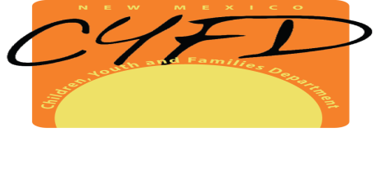
EMPLOYER STATEMENT
_______________________________
Name of Facility or Program
_______________________________
Mailing Address
_______________, _______________
City State Zip
_______________________________
Physical Address of Applicant’s Service

I, ___________________________________, authorized representative, hereby attest that _________________________________ is an applicant for employment, an employee, contractor or volunteer with our organization. This applicant, employee, contractor or volunteer requires a CYFD background check pursuant to 8.8.3 NMAC and has direct care responsibilities or potential unsupervised access to care recipients. I understand that by signing this statement, our organization waives any claim that this applicant, employee, contractor or volunteer does not have direct care responsibilities or does not have potential unsupervised access to care recipients in the event that he/she is determined to be an unreasonable risk and denied background check eligibility.
I further attest that our organization has or could have primary custody of children for twenty hours or more per week.
_______________________________
Signature of Employer Representative
_______________________________
Title
_______________________________
Phone Number
_______________________________
Date

