UNM’s Employee Wellness Internship / Field Experience Application
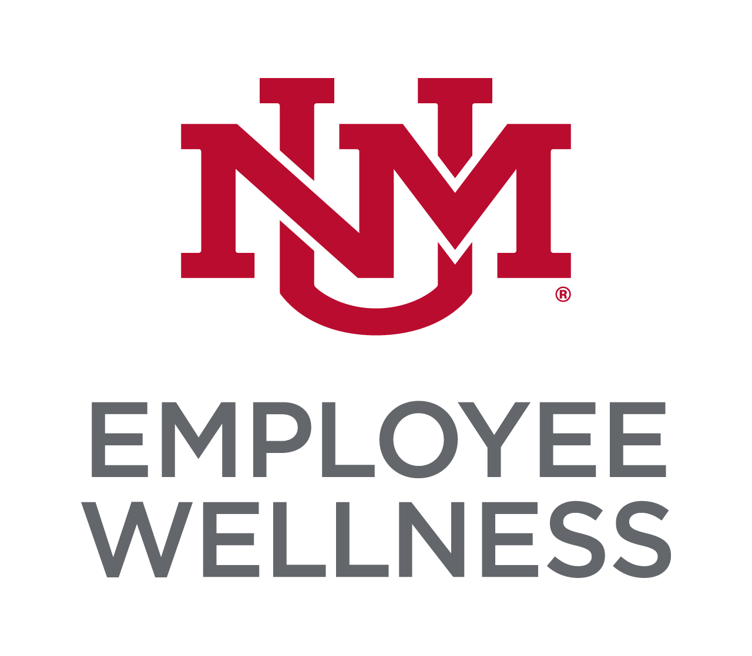

Name: ______________________________________ Phone: ___________________________

Email: ______________________________ Address: _________________________________

Academic Information
College: _____________________________ Degree Expected: ______________________________

Major Field of Study: _____________________ Minor: ________________________________________

Year in School: Desired Field Experience Dates: From ____________to___________
Employee Wellness’s regular business hours are Monday – Friday, 8:00 am – 5:00 pm. Within this time period, what is your available schedule?

Monday - hours: ___________________
Tuesday - hours: ___________________
Wednesday - hours: ___________________
Thursday - hours: ___________________
Friday - hours: ___________________

Field Experience Advisor: Phone:

I am interested in the following area(s):

Fitness Programs
Nutrition Programs
Stress Management
Tobacco Cessation
Tracking and Evaluation
Ergonomics / Back Injury Prevention

Promotion/Marketing
Other:

What personal qualities do you think will assist you in having a successful Field Experience with UNM’s Employee Wellness? (Please attach a separate sheet if needed)
__________________________________________________________________________________________________________________________________________

What are your short-term goals?
__________________________________________________________________________________________________________________________________________

What are your long-term goals?
__________________________________________________________________________________________________________________________________________

List special skills and training related to health, nutrition, and/or fitness (certifications, etc.)
__________________________________________________________________________________________________________________________________________

Please send resume, letter of recommendation, transcripts and a completed application to:
1700 Lomas Blvd. Suite 1400
Fax: (505) 277-8913
Email: wellness@unm.edu

