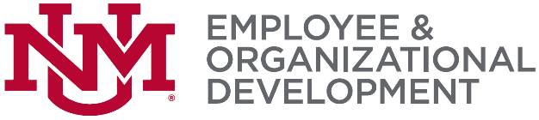

DECLARATION OF COMMITMENT – CAREER PATHWAYS

Please complete the following:

Career Pathways  Participant Information: | Supervisor’s Information:
Name: | Name:
Title/Position: | Title/Position:
Department: | Department:
MSC Code: | MSC Code:
Phone: Email Address: | Phone: Email Address:

I, ____________________________ on (date) _________ declare my commitment to completing the Career Pathways Certificate.

- I commit to the completion of any five courses listed below within one year from the declaration date.

Organizational Effectiveness | Personal Effectiveness
Intro to Professional Writing | Assertiveness for Better Communication
Creative Problem Solving | Communicate Effectively with your Supervisor
Customer Care …A Service You Provide | Changing Perspectives of Time Management
Email Correspondence | Emotional Intelligence in the Workplace
Treating Customers Right (Online Only) | Mastering the Art of Communication
Bullying in the Workplace (Online Only) | Discover Your DISC Behavior Style
Diversity: Skills for Collaboration (Online Only) | Seven Habits of Highly Effective People
 | Are You Well Aware

- I will actively participate in the Professional Development Series courses.
- Ask questions, contribute ideas, share experiences

- I will use the information I learn.
- Find opportunities to practice, use information and skills in the workplace, invite feedback

- I have informed my supervisor of my commitment to complete the Professional Development Series program.
We have agreed on the following goals related to the program:

Return form to:
Employee and Organizational Development
John & June Perovich Business Center
MSC01 1222
Fax: 277-1636
Phone: 277-1555
Email: eod.unm.edu
Attention: Professional Development Series

