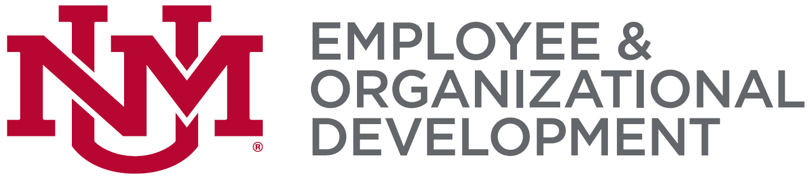

STATEMENT OF COMPLETION – CAREER PATHWAYS
Participant Information
Career Pathways Certificate Participant Information: | Supervisor’s Information:
Name: | Name:
Title/Position: | Title/Position:
Department: | Department:
MSC Code: | MSC Code:
Phone: Email Address: | Phone: Email Address:
Declaration of Commitment Date:

Certification Information
I, have completed the following courses that meet the requirements for completion of the Career Pathways Program.
Indicate which five courses you have completed below:
Organizational Effectiveness | Personal Effectiveness
Intro to Professional Writing | Assertiveness for Better Communication
Creative Problem Solving | Mastering the Art of Communication
Customer Care… A Service YOU Provide | Changing Perspectives of Time Management
Teamwork (all classes) | Emotional Intelligence in the Workplace
Treating Customers Right | Communicate Effectively with your Supervisor
Email Correspondence | Are You Well Aware
Bullying in the Workplace | Seven Habits of Highly Effective People
Diversity: Skills for Collaboration | Discover Your DiSC Behavioral Style
 | Building Bridges Across Generations at Work
Indicate you have completed UNM required training
All UNM required training (Safety, etc.)
Essay Assignment: Please write your essay, not to exceed one page in length, responding to the following questions (submit your essay with this form):
- How did the classes you took meet the goals you set for yourself when you started the program?
- What did you learn in the classes you took that you have applied to your job and/or life?

Participant Signature: ___________________________________________________ Date: ____________________

Return form to:
Employee and Organizational Development
John & June Perovich Business Center
MSC01 1222
Fax: 277-1636
Phone: 277-1555
Email: eod.unm.edu
Attention: Professional Development Series

