

**How to attach a document**

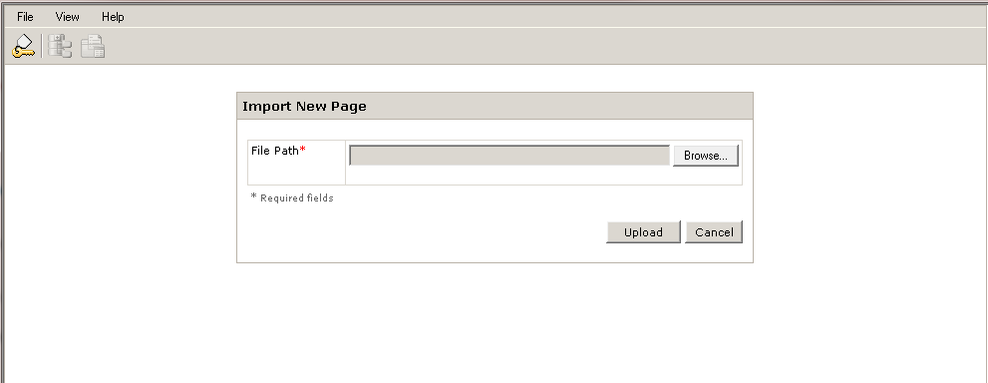

Click on the Browse button to locate the document you want to attach

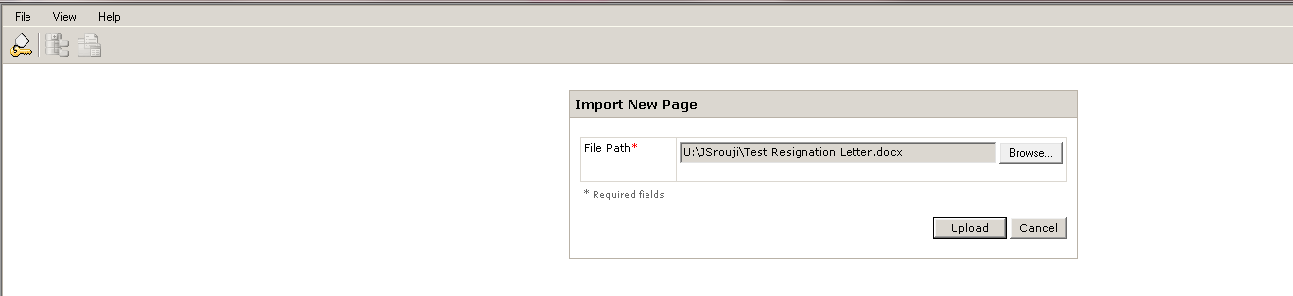

Click on the Upload button

**Note:** In order to maintain the integrity of the document it is recommended that all documents be converted to PDF prior to upload.

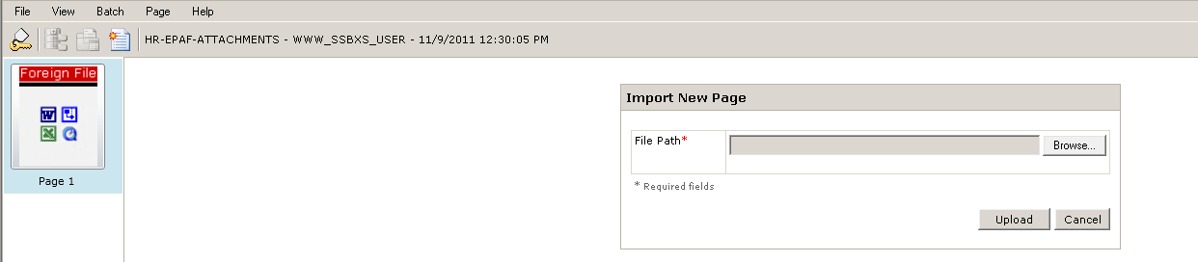

Click on the “New” icon

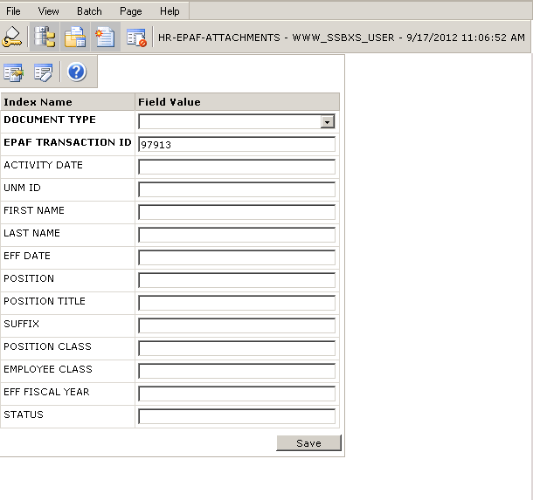

Click Save

Select the appropriate document type from the Document Type drop down menu. You do not have to enter any other information.

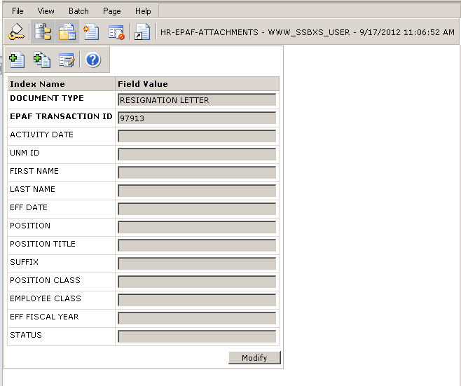

If the attachment has multiple pages, click on the “Attach All Pages” button.

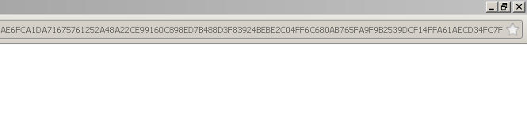

Close application extender by clicking on the X in the top right corner of your screen.

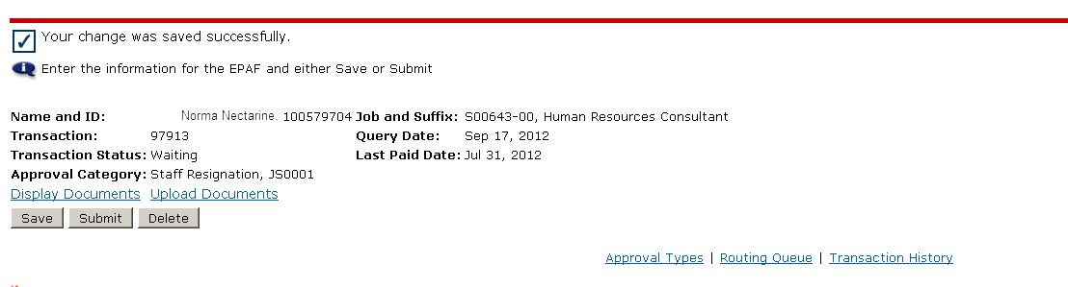

Click Save. The Display Documents link will appear. Click on ths link to view the document.