**EPAf queue summary**



**EPAF Originator Summary**

The EPAF Originator Summary page displays only those transactions that you have originated. This page contains two tabs, Current and History*.*

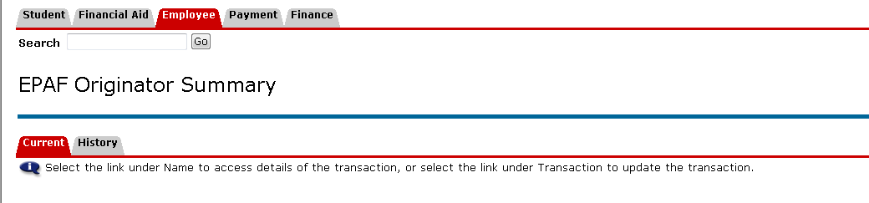

The Current tab is similar to an “inbox”. This Tab displays transactions that are currently in the originator queue awaiting action. For example, a transaction that has been saved but has not been submitted.

The “History” tab displays transactions the originator has already submitted. The originator does not need to take any action.

**Current Tab**

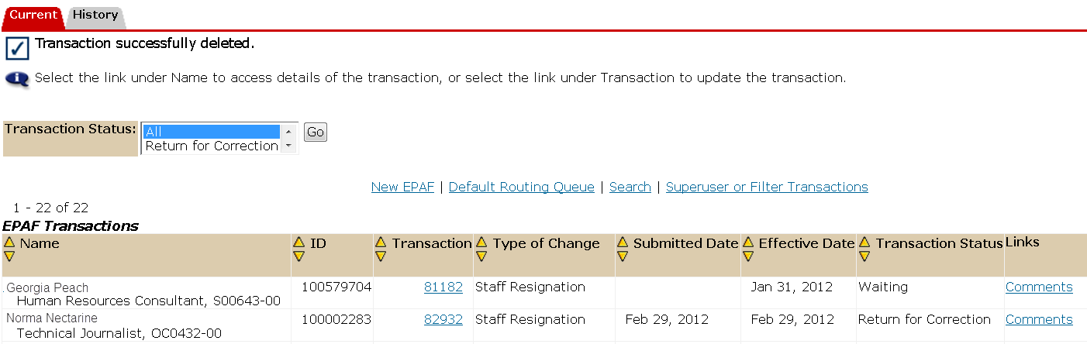

**Possible Transaction Statuses include:**

***Waiting -***If an EPAF has been created and saved (but not submitted), it remains in the waiting status.

***Returned for Correction-***If an EPAF contains an error or incorrect data, instead of approving it, an Approver will return it for correction. To view a returned EPAF, click on the employee’s name. The EPAF Originator has two options: Void or Update. Click **Void** to void the EPAF. This will permanently inactivate the EPAF. Click **Update** to make any changes to the EPAF.

**History Tab**

**Possible Transaction Statuses include:**

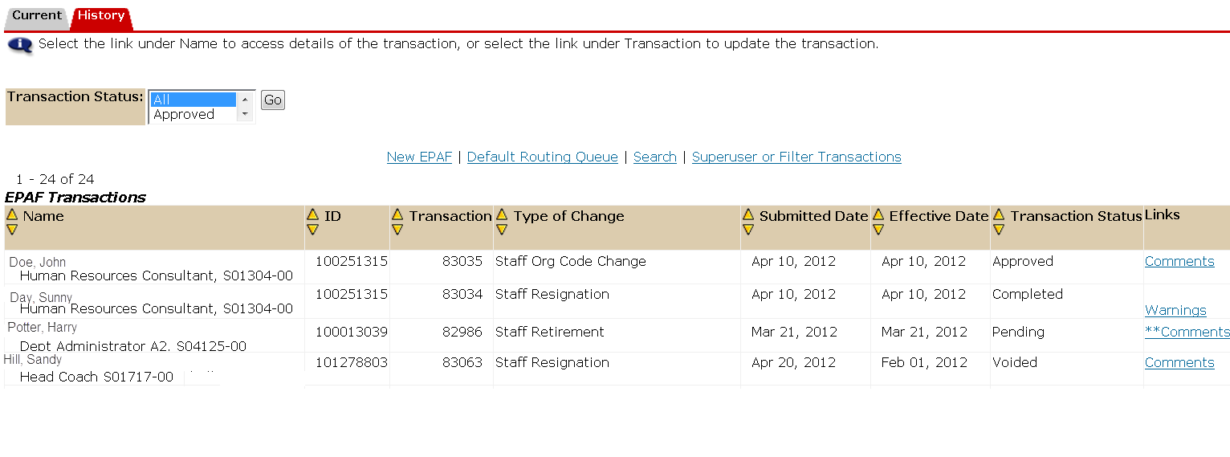

***Pending*** – The EPAF is waiting on approval.

***Completed*** The EPAF has gone through all the appropriate approval levels and changed the employee’s personnel record in Banner.

***Returned*** – The EPAF has been sent back to the originator for correction.

***Voided*** – The EPAF has been voided but its history remains available.

**EPAF Originator Summary Cont.**

**Originator Button Options**

**Save**

If you want to save your transaction with submitting, click on the “Save” button. If you save an EPAF transaction without submitting, this transaction will remain in your “Current” tab with a status of waiting.

**Delete**

If you have not submitted a transaction, you can delete the EPAF. This will remove the transaction from all approval levels, including the originator’s queue. (Reminder: Only the Originator can delete an EPAF).

**Void**

Originators can void their own transactions if they no longer want that transaction to be processed. You can only void a transaction AFTER it has been submitted. This transaction will be found in your “History” Tab. (Reminder: Only the Originator can void an EPAF).

**EPAF Approver Summary**

The EPAF Approver Summary contains all the EPAFs that have the Approver listed in the Approval Queues”. There are two types of approvers; one that is required to Approve the action in order for the EPAF to continue through the approval process or another to Acknowledge an FYI. FYI’s are sent to an Approver for informational purposes and do not require the Approvers approval in order for the action to proceed.

This page contains three tabs, Current, In my Queue, and History.

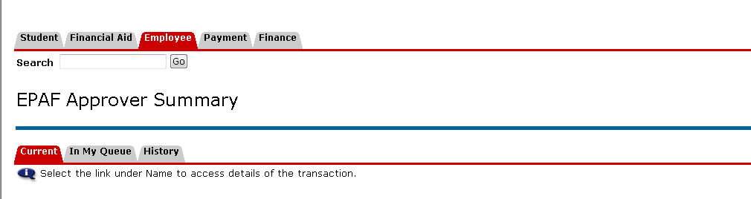

The approver Queue gives a third option that the originator queue does not include. The “In My Queue” tab displays EPAF transactions for which you have been selected as an approver. These transactions are currently sitting in the originators queue. Approval by you is not required at this time but will be at some point soon. The “Current” and “History” tab are the same as those listed above in the EPAF Originator Summary.

**Current Tab**

The Current tab is your EPAF inbox. This is where the EPAFs appear that require your approval or FYI.

**In My Queue**

The “In My Queue” tab displays EPAF transactions for which you have been selected as an approver. These transactions are currently sitting in the originators queue. Approval by you is not required at this time but will be at some point soon.

**History**

The History tab shows EPAFs that have been approved or acknowledged by the Approver.

**EPAF Approver Summary Cont.**

**Approver Button Options**

**Approve**

Approving an EPAF confirms the information is correct and authorized. Click “Approve to allow the EPAF to progress to the next approval level in the routing queue. Once you have “Approved” the EPAF it will be moved to your “History” Tab.

**Disapprove**

Disapprove should not be used. If you feel there is an issue with this EPAF, return it for correction.

**Return for Correction**

This option returns the EPAF to the Originator. It is important to add comments as to why this EPAF is being returned. The originator should correct and resubmit the EPAF. Once the transaction has been returned for correction, the originator will view the EPAF under their “Current” Tab. The approver can view the Return for Correction EPAF in their “History” Tab.

**Acknowledge**

This option acknowledges the information that is shared in the EPAF. When an Approver is FYIed on an EPAF, he or she cannot approve or return it for correction. This is the only option you will see if you have been set up as an FYI approver.