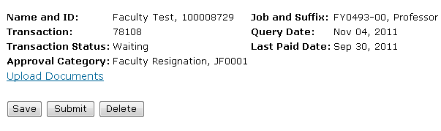

**FACULTY RESIGNATION EPAF**

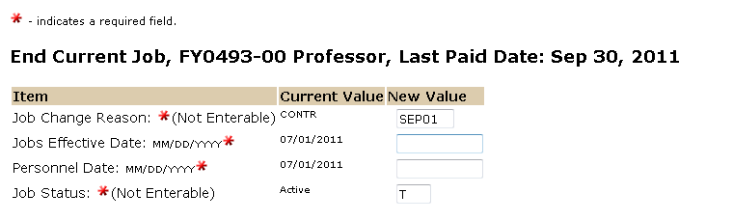

The personnel date is the faculty’s last date of employment. If retroactive and employee was overpaid, use last date of employment.

The Effective date reflects the faculty’s last date of employment. If this is a retroactive action and the employee has already been paid, then use the last paid date.

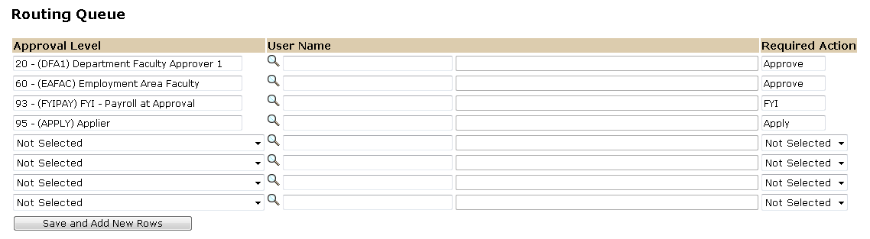

Approval Levels are pre-defined as a standard for system routing. If you require a second level approver, or an FYI, please add as needed.

The User Name is the person/entity associated with a specific approval level

The Required Action field identifies the appropriate action needed by the user.

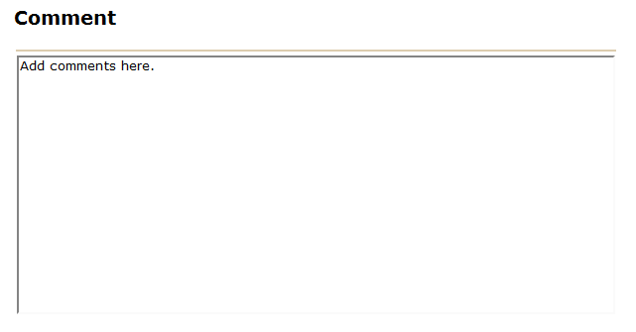

Use the comment box to document to document leave balances for resigning faculty member. For School of Medicine and College of Pharmacy a form will still be needed for 4 month notice approval. The forwarding address and checkout form are also needed prior to last date of employment.



To complete your Faculty Resignation EPAF, click on the upload botton at the top of the page to attach the Resignation Form (Resignation letter is optional). For instructions on how to attach a document to your EPAF please reference the BDMS job aid. Please note, you will have 5 minutes to attach your document otherwise the system will log you out and you will be required to log in again.