How to set up a proxy
- Prior to setting up proxies, it is important to verify that the individual being set up as your proxy has the appropriate role(s). In the example below, the individual must already have the role of EPAF-Dept Apprv Level 1-Staff.
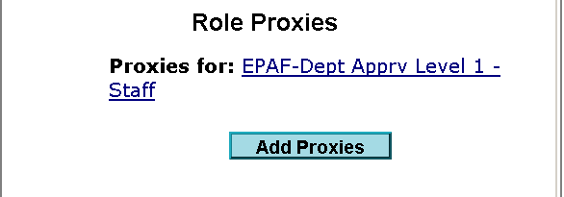
- Once the individual has the appropriate role, go to my.unm.edu and enter your NetID and Password.
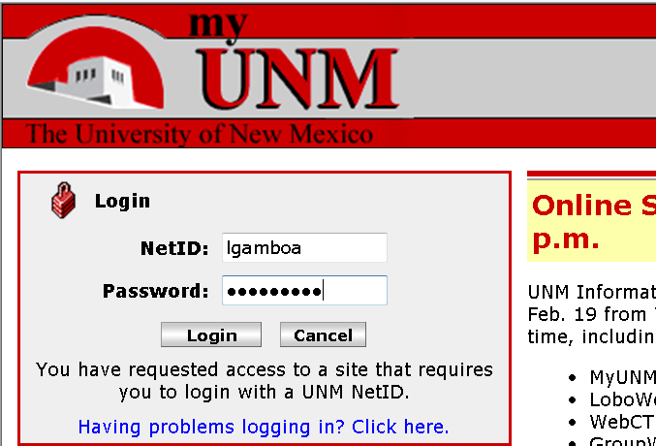
- Click on the Employee Life tab.
- Click on Banner Authorization Request link.
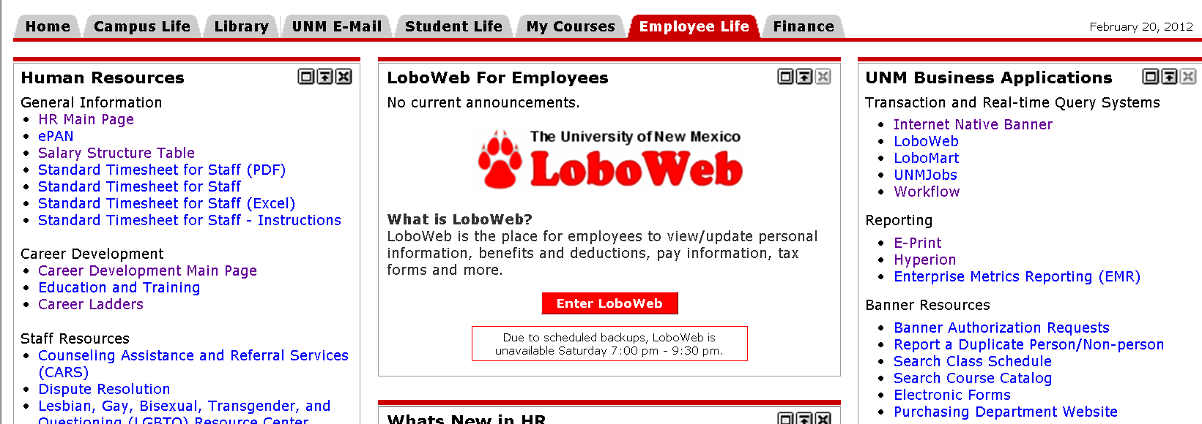
- Select Edit Request.
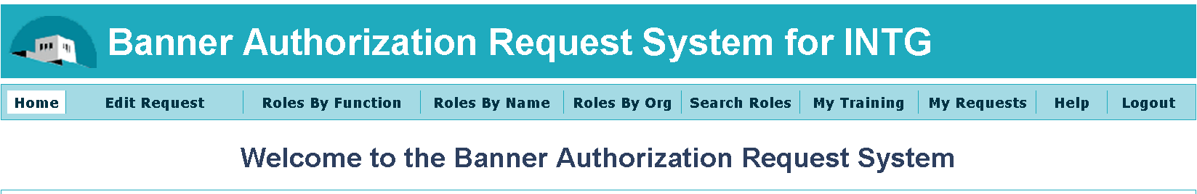
- If you are requesting a new role add your role now.
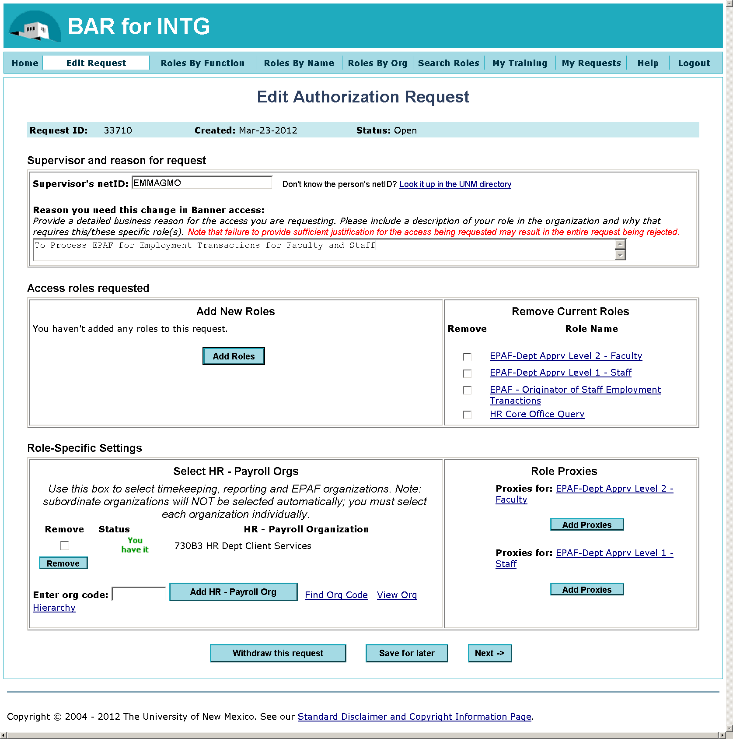
Add proxy here
Add role here
- To add a proxy click on the Add Proxies button for the appropriate role.
- A list of individuals with this role will display. Select your proxy from this list by highlighting their name.
- Click on the Save button.

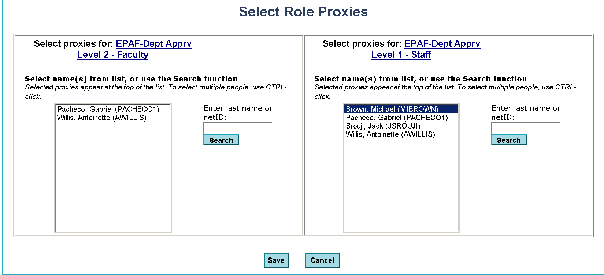

Note: If the name of the individual does not display, this person has not been set up with this role.
- This person’s name will now display under the appropriate role.
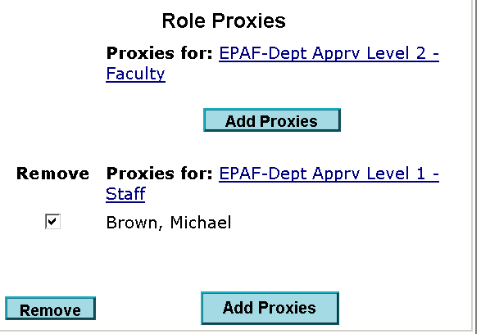
- Click on the Next button at the bottom of the page.
- Click on the Submit Request button at the bottom of the page.

