To request your EPAF roles:
Request epaf roles
- Go to my.unm.edu and enter your NetID and Password.
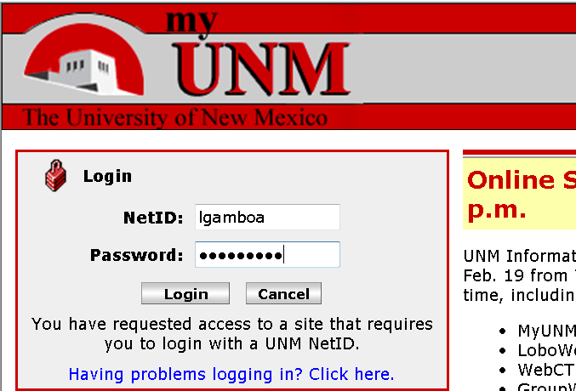
- Click on the Employee Life tab.
- Click on Banner Authorization Request link.
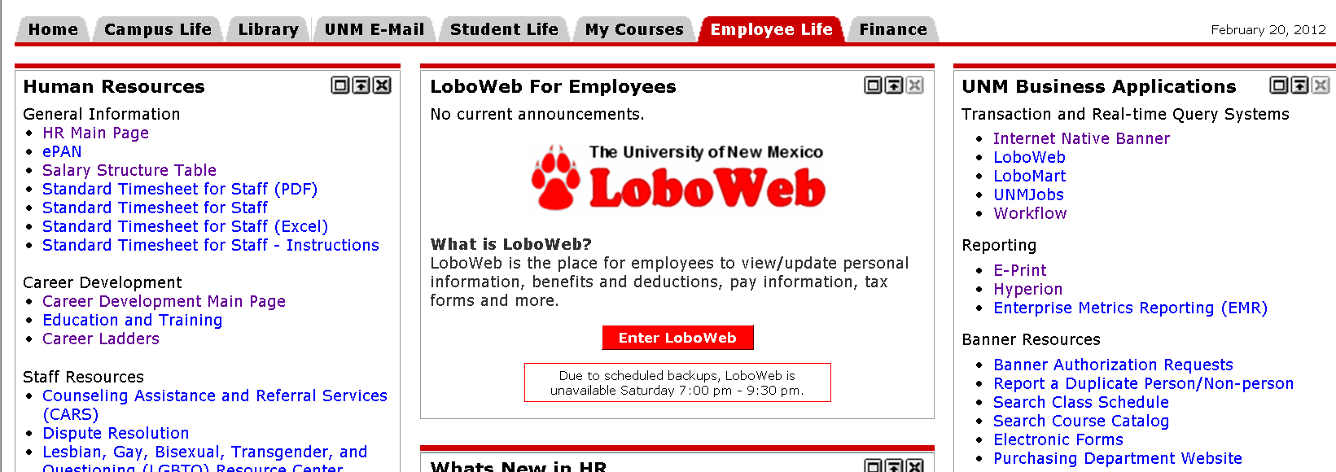

Start an authorization request
- If you currently have an incomplete request you will see an Open Saved Access Request button at the bottom of the page. Click on the button.
- If you do not have an existing request you will see an add/remove access roles button at the bottom of the page. Click on the button.
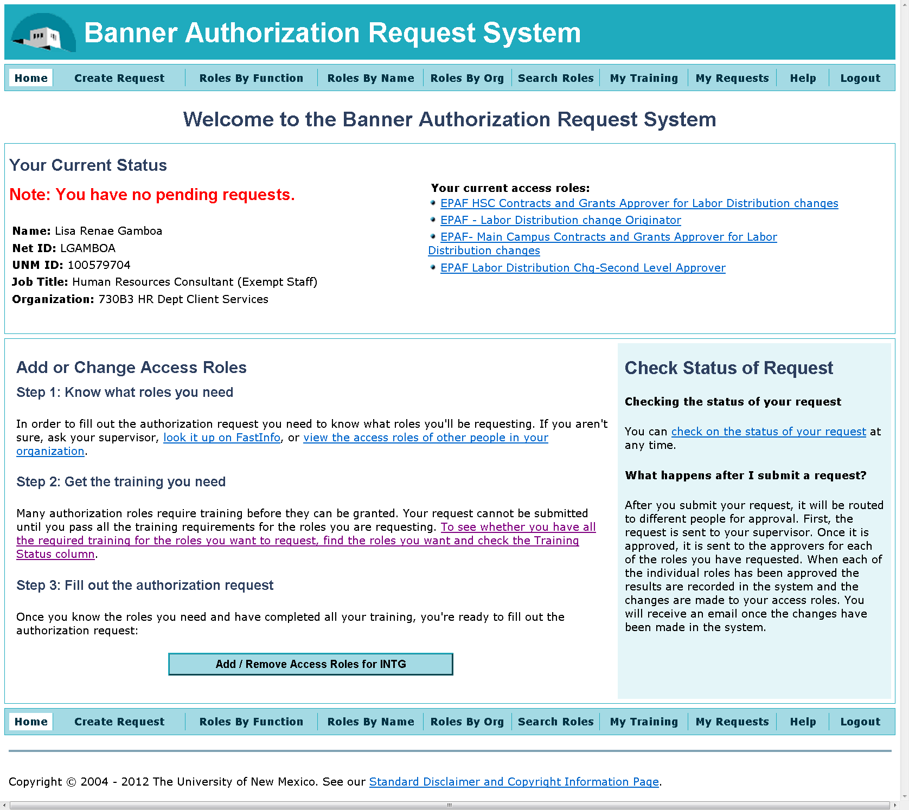
NOTE: If you have existing Banner access, your current authorization will automatically be copied into your new request.

- Enter your supervisor’s NetID. If you do not know your supervisor’s NetID, please use the hotlink to the UNM Directory to look it up.
- Explain the business reason for this role.
- Click on the Add Roles or Select Roles button.
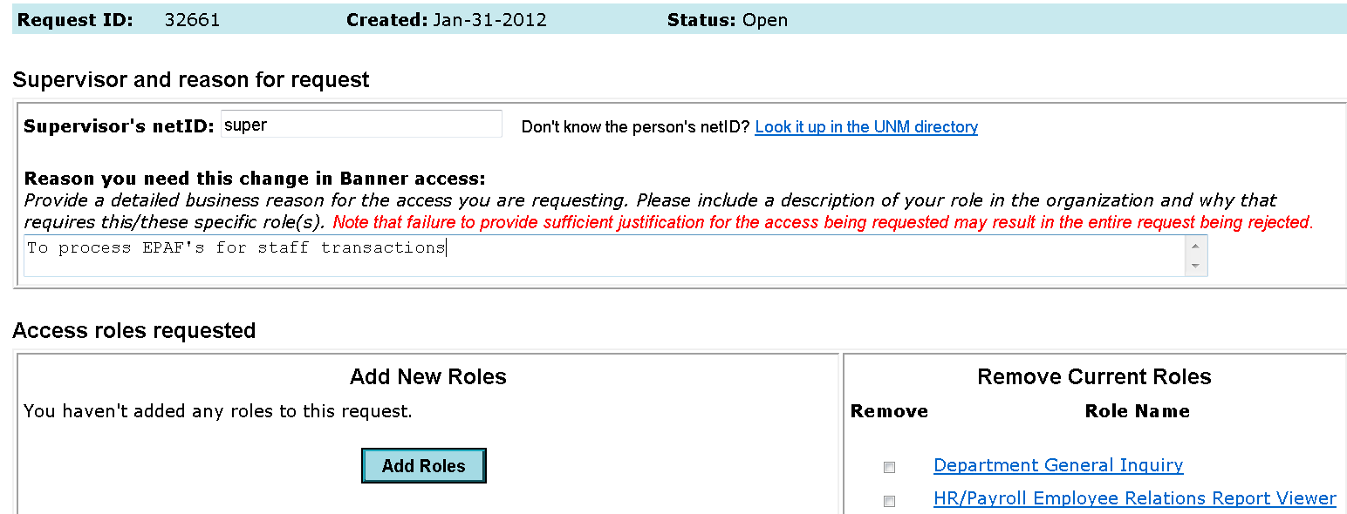
- Click on SHOW ALL ROLES
- Click on EPAF Employment Transaction Roles
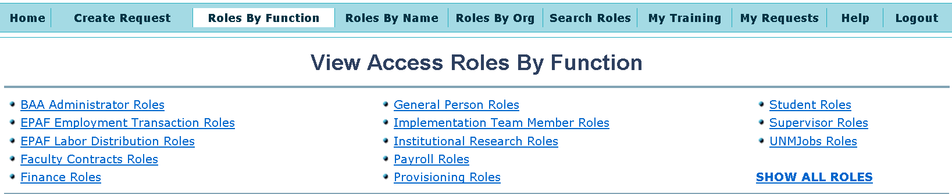
- Find the role(s) you will be requesting.
- If it indicates “need training”, click on the Need Training link.
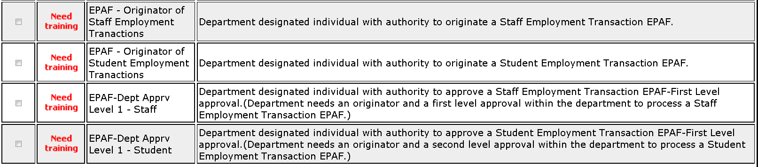

- The required courses for this role will be displayed.
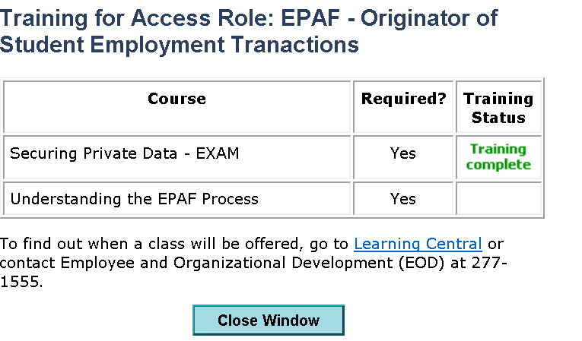
NOTE: In the example above, there are 2 required courses (Securing Private Data and Understanding the EPAF Process). Before a role can be requested, all required courses must be complete.
- If you need to complete a course, go to Learning Central.
NOTE: Understanding the EPAF Process is a course that contains 3 modules. Please take all 3 before requesting you EPAF role.
- Once your training is complete, click the check box next to the appropriate role.
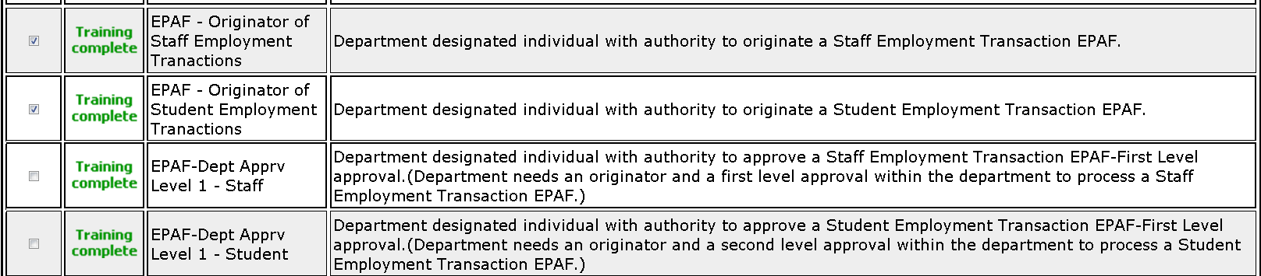
- Click on the Add Selected Roles to My Request button at the bottom of the page.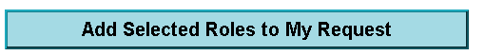

- Verify you have selected the appropriate role(s)
- Enter the approptiate org code
- Click on the ADD HR-Payroll Org button to add the org code to your request.

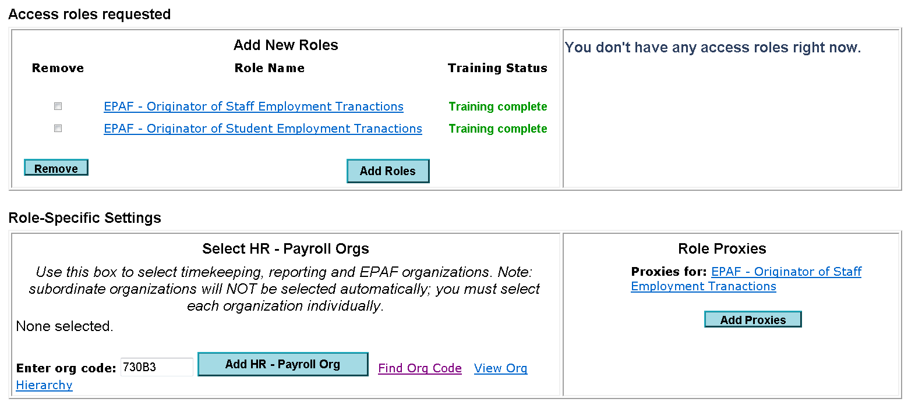
- Click on the Next button at the bottom of the page
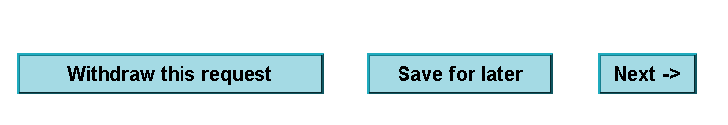
- Verify all information
- Click on the Submit Request button at the bottom of the page.

