RESIDENT PHYSICIAN END OF CONTRACT
Before initiating this EPAF consider the following:
- Has the employee met all requirements for completing the residency program? If yes, proceed with creating the Resident Physician End of Contract EPAF.
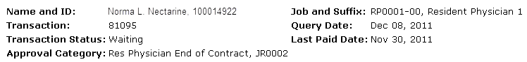

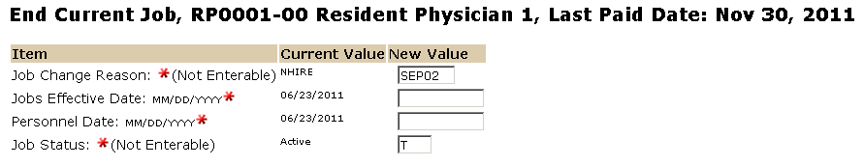
The Effective date reflects the employees last working day (consider any off cycle days that must be made up to complete the residency program.) If his is a retroactive action and the employee has already been paid use the last paid date.

\
The personnel date is the employees last working day, which should be the term end date.
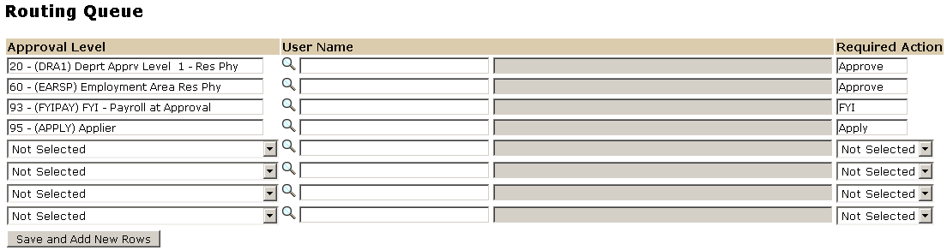

The Required Action field identifies the appropriate action needed by the user.

The User Name is the person/entity associated with a specific approval level

Approval Levels are pre-defined as a standard for system routing. If you require a second level approver, or an FYI, please add as needed.

Enter Comments.

To complete your End of Contract EPAF, click on the upload botton at the top of the page to attach the Check out list. For instructions on how to attach a document to your EPAF please reference the BDMS job aid. Please note, you will have 5 minutes to attach your document otherwise the system will log you out and you will be required to log in again.

