

**Staff Deceased EPAF**

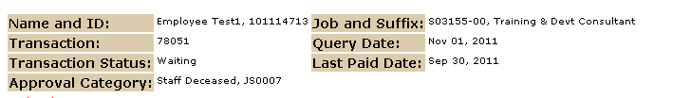



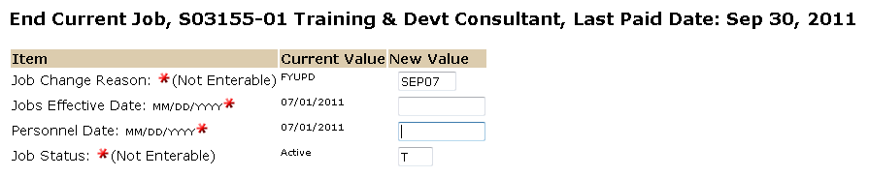

The Personnel Date is the employees last working day.

The Jobs Effective Date reflects the employees last working day unless this is a retroactive action and the employee has already been paid. In this case use the last paid date. See “Understanding EPAF Transaction Dates” for more information.

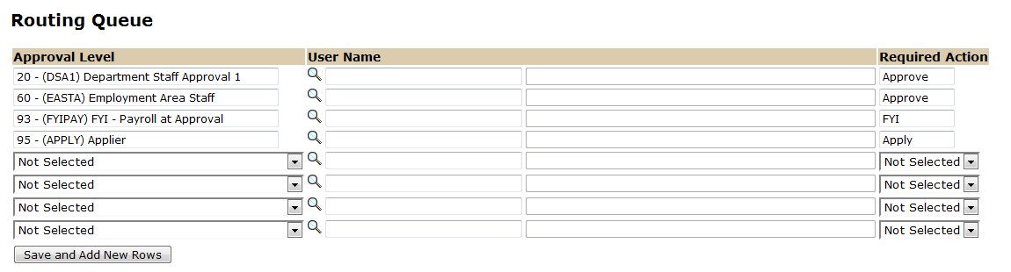

The Required Action field identifies the appropriate action needed by the user.

The User Name is the person/entity associated with a specific approval level.

Approval Levels are pre-defined as a standard for system routing. If you require a second level approver, or an FYI, please add as needed.

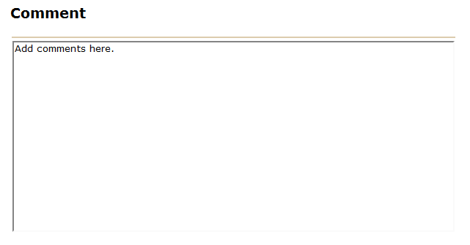

Use the comment box to document forwarding address (if applicable) and leave balances for employee.

