

**STAFF END OF CONTRACT/TERM**

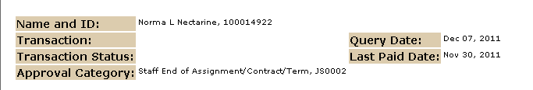

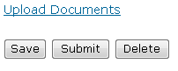

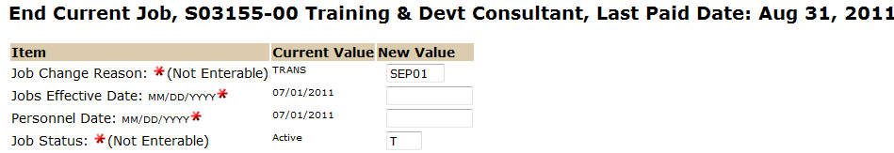

The Jobs Effective Date reflects the employees last working day unless this is a retroactive action and the employee has already been paid. In this case use the last paid date. See “Understanding EPAF Transaction Dates” for more information.

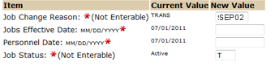

The Personnel Date is the employees last working day, which should be the term end date.

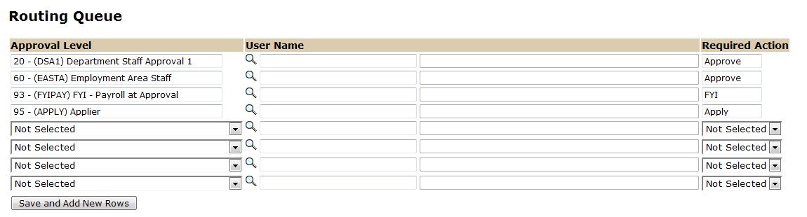

Approval Levels are pre-defined as a standard for system routing. If you require a second level approver, or an FYI, please add as needed.

The Required Action field identifies the appropriate action needed by the user.

The User Name is the person/entity associated with a specific approval level.

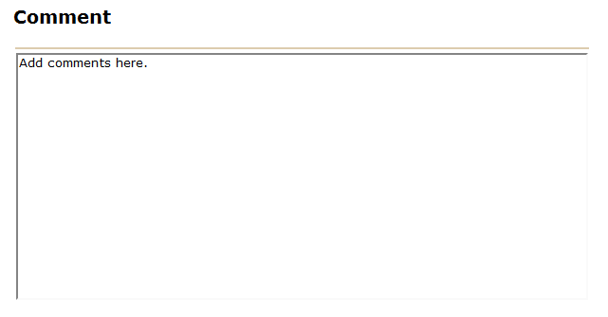

Use the comment box to document forwarding address (if applicable) and leave balances for separating employee.



To complete your Staff End of Contract/Term EPAF, click on the **Upload Documents** button at the top of the page to attach the End of Term Notification Memo. For instructions on how to attach a document to your EPAF please reference the Attaching Documents Job Aid. Please note, you will have 5 minutes to attach your document otherwise the system will log you out and you will be required to log in again.