STAFF EXEMPT CHANGE IN APPOINTMENT PERCENT EPAF

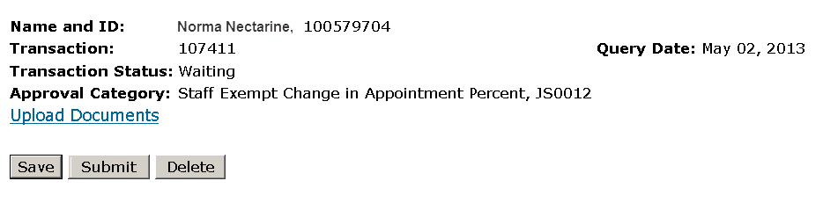
The Jobs Effective Date reflects the date the employee will begin being paid at this percent. If this is a retroactive transaction then use the day after the last paid date.

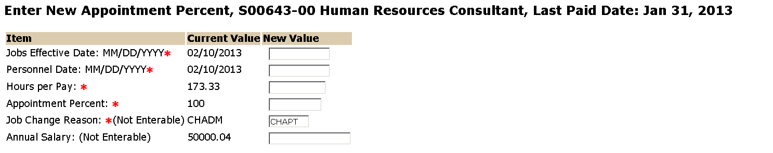
Enter the new appointment percent. This percent must be greater than 1. For example 50% should be entered as 50 not .50
The Personnel Date is the date this appointment percent will take effect.
Enter the Hours per Pay that correspond with the appropriate appointment percent (see below). If you do not see the appointment percent below use the following formula:
173.33 x (new appointment percent) = Hours per Pay.

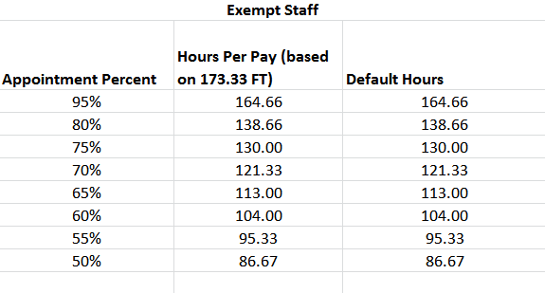

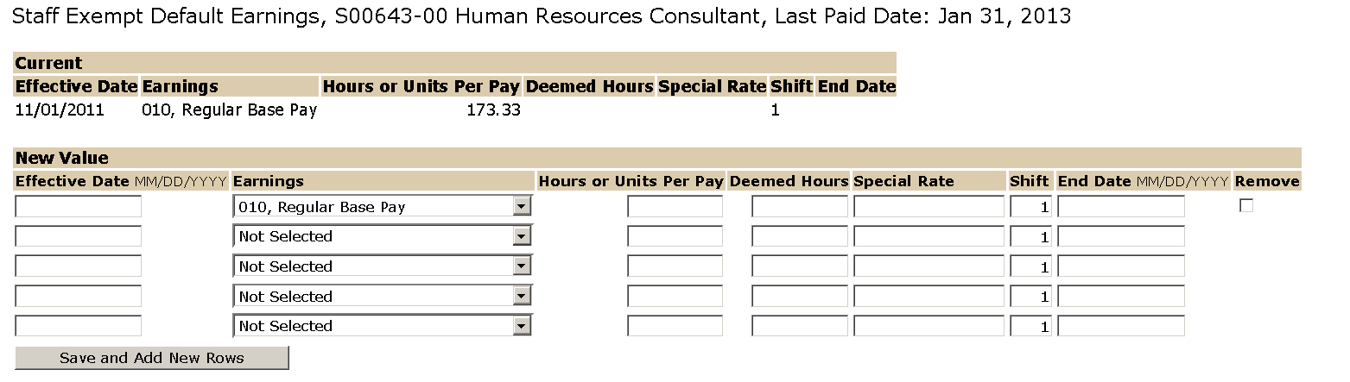
Replace the default value with new Hours per Pay entered above.
Do not change or add the earnings.
Replace the default value with the date this appointment percent will take effect. This date must match the Jobs Effective date.

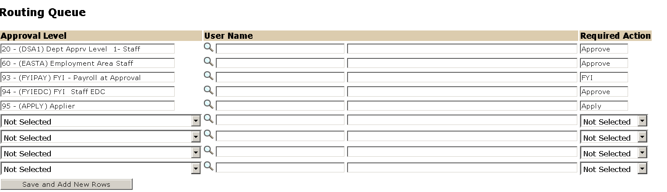
The Required Action field identifies the appropriate action needed by the user.

The User Name is the person/entity associated with a specific approval level.

Approval Levels are pre-defined as a standard for system routing. If you require a second level approver, or an FYI, please add as needed.

If this transaction will result in change of E-Class, please note here. Also, use the comment box to communicate any other relevant information regarding this transaction.

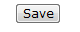
To complete your Staff Exempt Change in Appointment Percent EPAF, click on the upload button at the top of the page to attach the Change in Appointment Percent Form or the Decrease in Appointment Precent Resulting in Change of E-Class Form. For instructions on how to attach a document to your EPAF please reference the Attaching Documents job aid. Please note, you will have 5 minutes to attach your document otherwise the system will log you out and you will be required to log in again.

Note: If you are processing a Term Extenstion EPAF and a Change in Appointment Percent EPAF please processes the Term Extention EPAF first.

