

**Staff Org Code Change EPAF**

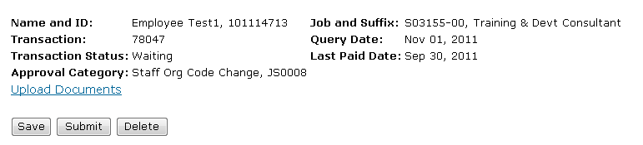

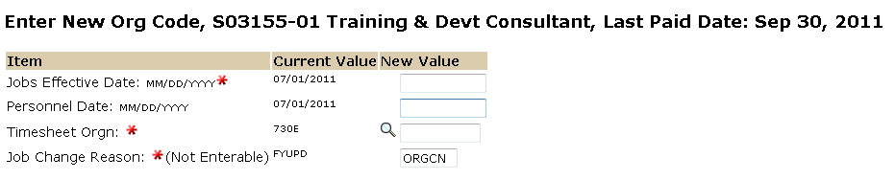

The date the new timesheet org will take effect.

Enter the new timesheet org code in this field.

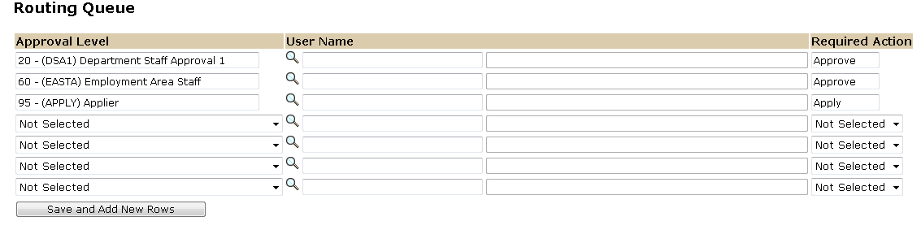

The Required Action field identifies the appropriate action needed by the user.

The User Name is the person/entity associated with a specific approval level.

Approval Levels are pre-defined as a standard for system routing. If you require a second level approver, or an FYI, please add as needed.

