

**staff Update Supervised By EPAF**

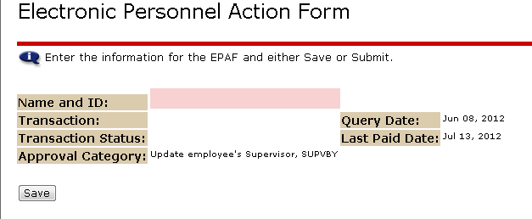

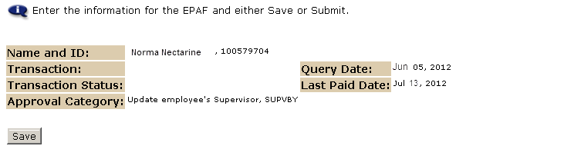

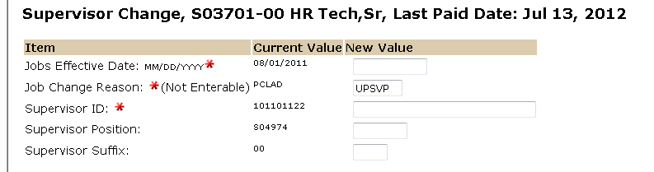

Enter the new supervisor’s UNM ID, position number, and suffix. Please note- entering the wrong position number will result in an EPAF error. If the new supervisor has more than 1 job assignment, it is important that the correct position number is entered. **Note: Supervisor must be a UNM employee.**

No

Enter the date this update will take effect.

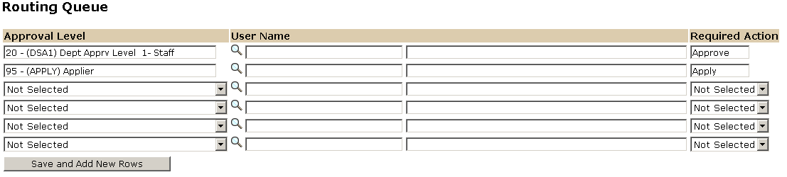

Approval Levels are pre-defined as a standard for system routing. If you require a second level approver, or an FYI, please add as needed.

The User Name is the person/entity associated with a specific approval level

The Required Action field identifies the appropriate action needed by the user.

