

**Student Job Extension epaf**

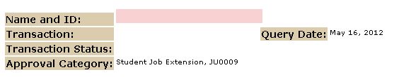



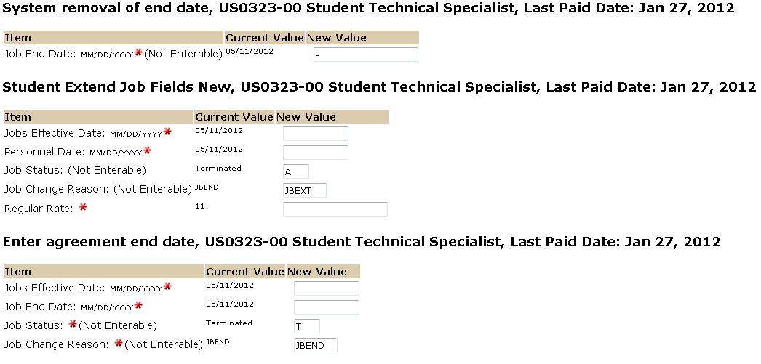

The Jobs Effective date and Personnel Date should reflect the new start date. Must be after the last paid date listed above.

The Job End Date, and Jobs Effective Date should reflect the assignment end date. All work study assignments must have an end date. For summer, end on last class date of student’s summer class but if the student is enrolled for fall, end on 8/10/12. For fall only, work study ends on 12/14/12. For fall/spring, end on 5/10/13.

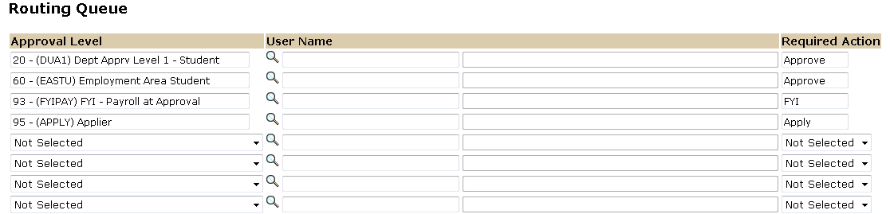

The Routing Queue is a Pre-defined standard of approval levels. If you require a second level approver or an FYI, please add as needed.

The Required Action field identifies the appropriate action needed by the user.

The User Name is the person/entity associated with a specific approval level.

Use comments box to document reasons for requesting a salary change for student.