

**student Lobotime clock update**

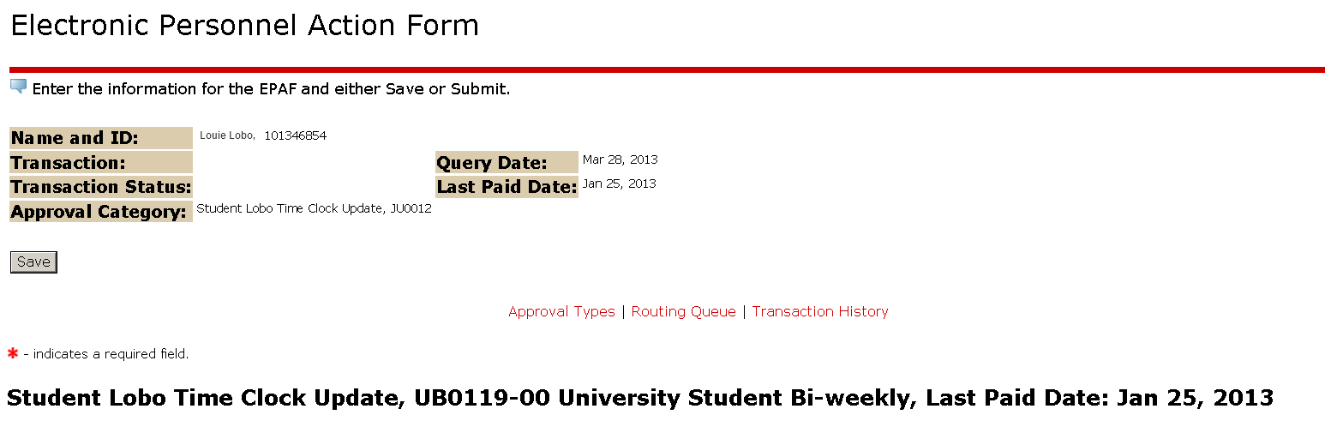

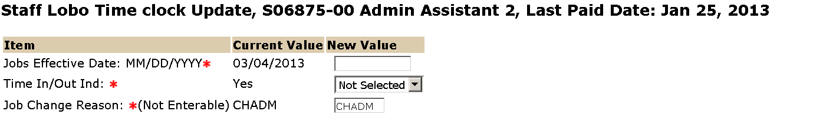

Enter the start date of the next pay period.

Select “YES” if the individual will be using a time clock ONLY. Select “NO” if the individual will be using a clock and PC to clock in and out. **Do not** select “Remove”. This will cause and error and your EPAF will not process.

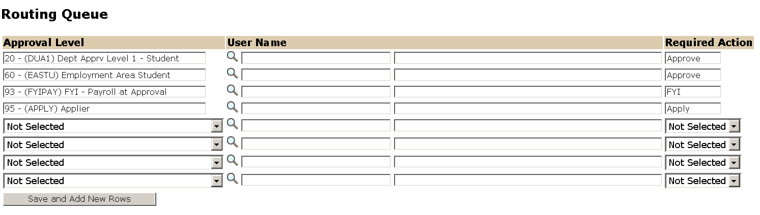

Approval Levels are pre-defined as a standard for system routing. If you require a second level approver, or an FYI, please add as needed.

The User Name is the person/entity associated with a specific approval level

The Required Action field identifies the appropriate action needed by the user.

