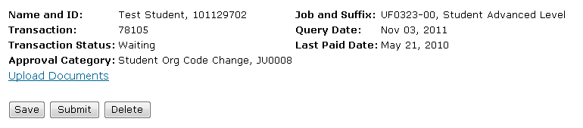

**Student Org Code Change EPAF**

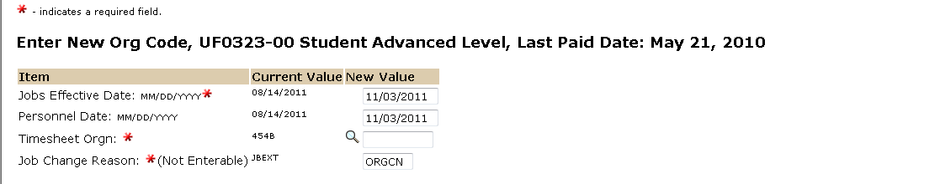

The personnel date reflects the next available effective pay period.

The Effective date reflects the next available effective pay period.

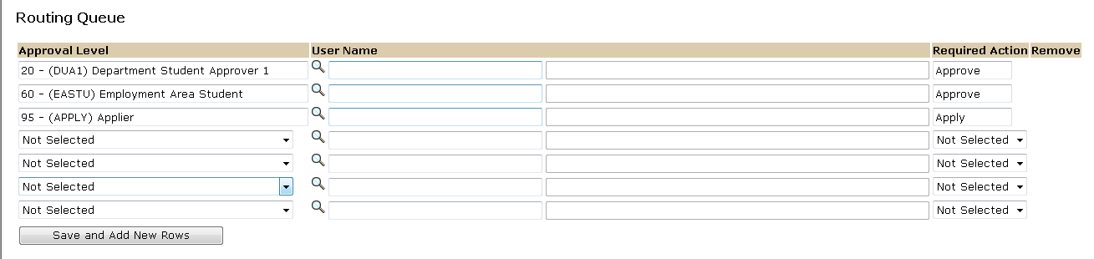

The User Name is the person/entity associated with a specific approval level.

Approval Levels are pre-defined as a standard for system routing. If you require a second level approver, or an FYI, please add as needed.

The Required Action field identifies the appropriate action needed by the user.

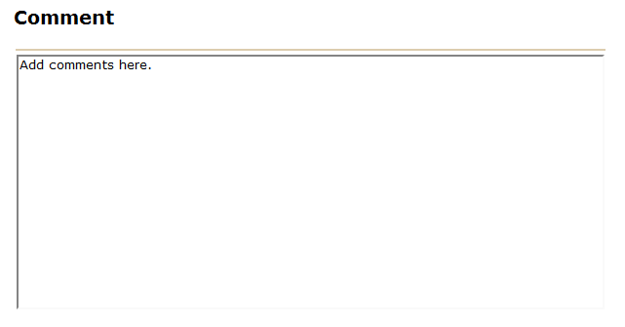



If you chose to attach a document please click on the upload botton at the top of the page to attach a document. For instructions on how to attach a document to your EPAF please reference the BDMS job aid. Please note, you will have 5 minutes to attach your document otherwise the system will log you out and you will be required to log in again.