Email notification in UNMJobs Quick Reference Sheet
Department Originators can now choose to automatically notify applicants by email if the applicant is not hired for a position, or if the posting has been canceled.
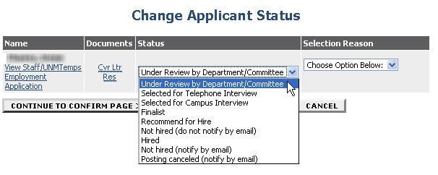
When logged in as a Department Originator in the View/Edit Posting page, you may choose to send emails by selecting specific statuses within the Change Applicant Status screen:

Choose Not Hired (do not notify by email) to select an applicant as Not Hired, and not send out an email to that applicant.
Dear Applicant:
This email is being sent to notify you that the University of New Mexico has decided not to fill the position of insert Working Title> (posting number <insert posting number>) in <insert Department> for which you recently applied. Thank you for the interest you have shown for employment in this position with University. We encourage you to apply for any other job openings that may be of interest to you.
The University of New Mexico

Choose Not Hired (notify by email) to automatically send the following:
Dear Applicant:
Thank you for your interest in employment at the University of New Mexico. The final screening of applications for the position of <insert Working Title> (posting number <insert posting number>) in <insert Department>, has been completed. Your application was considered, but you were not selected. We encourage you to continue visiting our website and applying for positions that interest you. Our employment opportunities can be found at https://UNMJobs.unm.edu
The University of New Mexico

Please note the system will automatically insert the specific working title, department name, and posting number.

Choose Posting Canceled (notify by email) to automatically send the following:
Dear Applicant:
This email is being sent to notify you that the University of New Mexico has decided not to fill the position of <insert Working Title> (posting number <insert posting number>) in <insert Department> for which you recently applied. Thank you for the interest you have shown for employment in this position with the University. We encourage you to apply for any other job openings that may be of interest to you.
The University of New Mexico

