**How to Request a UNM*Temp***

**Before completing a UNM*Temps* Request:**

* Confirm that you (or someone in your department) have the **Staff Department Originator role** in **UNMJobs**
* Look up the **TS** pooled **position number** under the organization that the temporary will be paid (found in e-Print all vacant positions report)
* Determine **job duties**, **title** and **pay** for the temporary employee

**Have questions regarding appropriate titles and pay?   
Call UNM*Temps* at (505) 277-2013.**

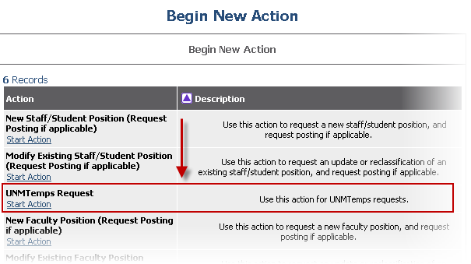

**To Request a UNM*Temp*:**

Ensure that you are under the **Department Originator** View in UNMJobs.

* If you are *not* logged in under the Department Originator View, select the “Change User Type” link in the red menu (left side of the page)

Select the **Begin New Action** link (in the red menu), then select the **Start Action** link under “**UNMTemps Request**” (see screenshot)

* Choose a title from the “Position Class Title” drop down box.
* Click **Select and Continue** once appropriate title is selected
* Review Position Class Title and continue to **“Position Details”** tab
  + You may also change the classification at this step, if you decide that the original selection is not appropriate
* Complete the required fields:
  + Note: You have the option to request a temporary employee by name or for UNM*Temps* to competitively place a temporary employee
    - For “Request-by-Names”, ensure that the candidate meets all minimum qualifications for the selected title
    - “Request-by-Names” are *not eligible* for temp-to-regular appointment
  + Indicate the required skills/duties in the appropriate field
* Continue to **“Funding”** tab
  + Select **Add New Entry**, then select the appropriate Index Code
  + If splitting Labor Distribution %, ensure the total % = 100
  + The Labor Account Code is 20P0
  + Click the **Add Entry** button
* Continue to **“Comments”** tab
  + Please use this tab to let UNM*Temps* know:
    - (For “Request-by-Names”) The candidate’s e-mail address and phone number
    - (For “Request-by-Names”) If you request UNM*Temps* to complete reference checks
    - If your department is currently on LoboTime
    - Who will need access to review the applicants
    - Any additional information we need to know about the request

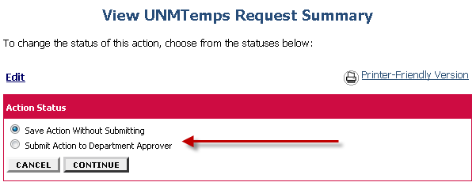

**Submit to Approver:**

* Once all applicable tabs are filled out you can either select:
  + “**Save Action Without Submitting**” if you want to come back to the request later *or*
  + “**Submit Action to Department Approver**”
* Once the Approver reviews the request, they can either choose :
  + “**Submit Action to Dean/Director,**”
  + “**Return Action to Submitter**” if they have questions,
  + “**Submit Action to UNMTemps**” if they approve the request, *or*
  + “**Delete Action and Remove from Queue**,” if they wish to completely remove the pending action
* The UNM*Temps* Request will route to the UNM*Temps* queue once the Department Approver approves the request

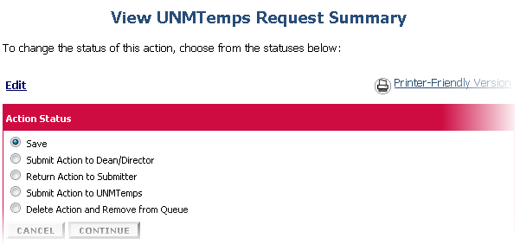

**Questions? Call UNM*Temps* at (505) 277-2013**

* UNM*Temps* will acknowledge your request within 24 hours of receipt and process the hire as quickly as possible
  + Note: UNM*Temps* follows UNM policies and procedures for placement of temporary employees in the areas of meeting minimum qualifications, completing reference checks, and any additional conditions of employment (i.e., background checks, fingerprinting, EOHS physicals, etc.)
  + Note: Temporary employees are ***not clear* to begin an assignment** until a **“clear to start” e-mail** is received from UNM*Temps*; the Department Contact will be copied on this communication.
* The department does not need to process a posting or hiring proposal for the temporary employee in the system; UNM*Temps* will process these transactions
* Please remember that your time keeper will need to refresh time entry to capture updated assignments in Banner

**Next Steps:**