BUSINESS CASE FORM

Please complete the form below and submit it to your project sponsor.

Background to the project (PLEASE KEEP BRIEF)

General aims(s)

Initial Risks

Expected Outcomes

Benefits of running with this project

Initial estimates of cost and time

$:

Time:

Outcome of the business case

Decision from (x x)

Date

PROJECT REPORTING FORM

Project Title: |  | Number:
Project Sponsor: | Project Manager:

Progress Report | Report No.

RAG Status*: RED / AMBER / GREEN
Headlines

Tasks, Milestones, Outcomes delivered this period |  |  |  |  |  |  | Completion dates
Tasks, Milestones, Outcomes |  |  |  | Comments |  |  | Plan | Actual
Major Risks and Issues Include an assessment of the impact and any actions taken

Recommendations and Requests for Decisions or Support

Tasks, Milestones, Outcomes scheduled for next period |  |  |  |  |  |  | Completion dates
Tasks, Milestones, Outcomes |  |  |  | Comments |  |  | Plan | Forecast
* RED | "Major concern - escalate to the next level" Slippage greater than 10% of remaining time or budget, or quality severely compromised. Corrective Action not in place, or not effective. Unlikely to deliver on time to budget or quality requirements
AMBER | "Minor concern – being actively managed” Slippage less than 10% of remaining time or budget, or quality impact is minor. Remedial plan in place.
GREEN | "Normal level of attention" No material slippage. No additional attention needed

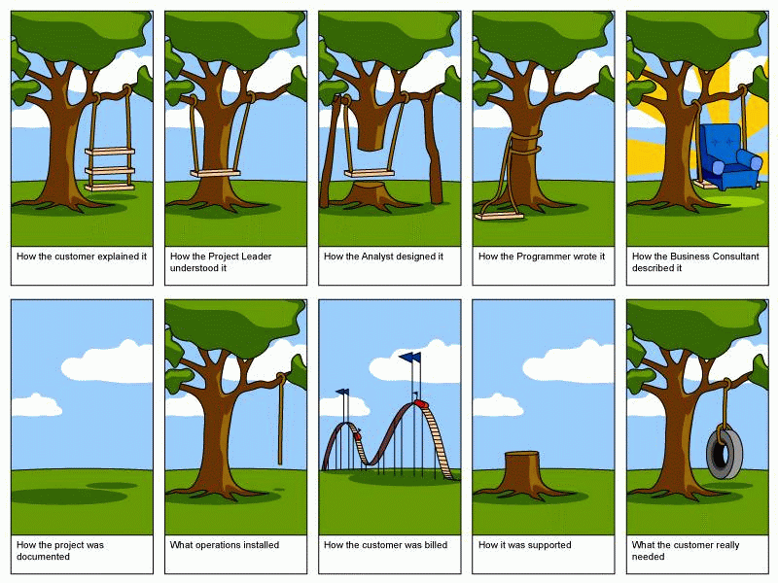
Project Debrief
Date

Plus | Delta
Lessons Learned

Next steps:

Project Request
& Project Plan

<Title>

Plan Version: | 0.1
Template Last Updated: | 9/23/2010 2:01:00 PM
Date Submitted:
Submitted by:
Executive Sponsor:
Expected Start Date:
Expected End Date:

Part 1: Project Request

- Project Summary
  - <What will this project accomplish?>

- Need Statement
  - <Why is this project being proposed?>

- Overview of Project Scope and Objective(s)
  - <What are the objectives of this project, and what is in scope?>

- Project Benefits
  - <What are the quantitative and qualitative benefits of this project?>

- Alignment with Strategic Priorities
  - <How do the objectives of this project align with the University’s strategic priorities?>

- What are the consequences if this project is not completed?
  - <What will happen if this project is not done by the date specified?>

- Dependencies
  - <What is dependent upon this effort, and what is this effort dependent upon?>

- Project Roles & Responsibilities

Project Role | Project Responsibility | Name | Title | Dept | Estimated Time Commitment (total hrs)
Executive Sponsor | An executive-level manager who interacts with the project team leader and acts as liaison with other executive staff members in taking high-level responsibility to champion, guide, and monitor a given project.
Customer Management Sponsor | Provides authority in the functional area to work on the project, maintains priority of functional expertise needed by IT
IT Management Sponsor | Provides technical authority and guidance and maintains the IT project priorities
Project Manager (In some cases, may be the same as Functional Lead) | Defines and maintains project plan. Responsible for all project activities.
Functional Lead | Defines, plans, controls, and leads the work of the functional participants. Defines and maintains project requirements
Technical Lead | Defines, plans, controls, and leads the work of the technical participants. Coordinates integration with existing systems.
Project BPOs / Steering Committee | Key Business Process Owners participating in and/or affected by project
Project Team | Provide the skills and effort to perform the work.
IT Security | Security approvals
Other Stakeholders | Other stakeholders who should be consulted

- Project Request Approvers
  - Those providing approval for Part 1, the Project Request

Date Reviewed:

Comments:

Reviewers:
Name | Title | Dept | Signature

Part 2: Project Plan

- Major Project Milestones and Deliverables
- Milestones are significant events; deliverables are outcomes or products that are produced as part of the project
Event/Outcome | Milestone (M) or Deliverable (D)? | Planned Completion Date | Owner | Resources Needed

- Scope
- Scope helps define the limits, expectations, and dependencies of the project. It includes any business functions, systems, projects, groups, and technologies that are supported, impacted, or dependent upon the project, as well as those that are not, and those that are uncertain.
Scope Element | Additional Hours | In Scope / Out of Scope / Uncertain | Team Recommendation

- Communication Plan
- Who are those that will be affected, or can be affected by the project? How will stakeholders be kept involved and informed about the project status?
Stakeholder/Audience | Method of Communication | Responsible Person | Frequency and/or Date

- Training Plan Overview
- What training will be needed to support successful project outcomes? Who is the target audience? Who are the lead persons responsible for the training development and delivery, and by what date will the training need to be accomplished?

Target Audience | Training Objectives | Person Responsible for Training Development | Person Responsible for Training Maintenance | Initial Delivery Date

- Risk Mitigation Plan
- What risks exist in the project? What is the probability they will occur? What impact will they have, and what strategy will be employed to alleviate them? What is the likely date by when the risk plan strategy will be initiated?
Risk | Likelihood  High (H), Medium (M), or Low (L) | Impact  High (H), Medium (M), or Low (L) | Risk Plan or Mitigation Strategy | Person Responsible | Strategy Initiation Date

- Assumptions, Constraints, and External Dependencies
- Assumptions are premises believed to be true regarding the project plan. Constraints are limits that will be placed on the project plan. Dependencies are aspects of the project that rely upon or are influenced by external aspects.
Element | Assumption (A) / Constraint (C) / Dependency (D)

- Project Budget (If applicable)
- Give title of each person working on project. Budget should include line item detail for each category.
 | Area | Hrs | $ | Functional Dept. Project Costs | ITS Project Costs | Functional Dept. Recurring Costs | ITS Recurring Costs
UNM Internal Dollars/Non-Discretionary | STAFF HOURS
 | Student
 | Financial Aid
 | Finance
 | HR/Payroll
 | Shared Components
 | Budget
 | Advancement
 | Platforms/Systems
 | Database
 | Network/Telecom
 | Customer Support
 | Total - Internal Labor :::::::::: |  |  | 0 | 0 | 0 | 0
D i s c r e t i o n a r y F u n d s | Hardware (Description & Vendor Name) | #Units | $
 |  |  |  | 0 | 0 | 0 | 0
 | Software (Description & Vendor Name) | #Units | $
 |  |  |  | 0 | 0 | 0 | 0
 | Staff Training (Description & Vendor Name)  Keep in mind fixed costs while in training… | Hrs | Rate
 |  |  |  | 0 | 0 | 0 | 0
 | Consulting /Term (Include Travel & Other Expenses)  Keep in mind standard rates, e.g. SIG, SCT, etc… | Hrs | Rate
 | Other Costs | 0 |  | 0 | 0 | 0 | 0
 | Total - External Costs :::: | 0 |  | 0 | 0 | 0 | 0
 | GRAND TOTAL :::

- Capital Funding Sources (If applicable)
- Note procurement approaches.
Index Code | Budget owner | Amount | Limitations (if any)

- Recurring Funding Sources (If applicable)

Index Code | Budget owner | Amount | Limitations (if any)

- Alternative Funding Sources (if applicable)

Funding options | Person responsible for budget request

- Project Plan Approvals

Date Reviewed

Comments:

Reviewers
- Reviewers are those persons providing approval for Part 2, the Project Plan

Name | Title | Dept | Signature

