

**EPaf login job aid**

Go to [my.unm.edu](https://my.unm.edu/cp/home/displaylogin) and enter your NetID and Password.

Click on the Employee Life Tab

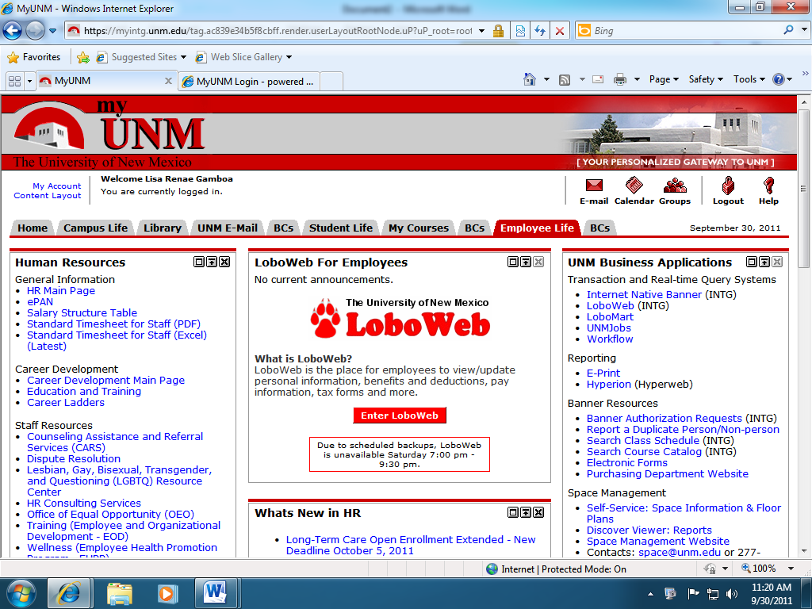

Click on the LoboWeb button

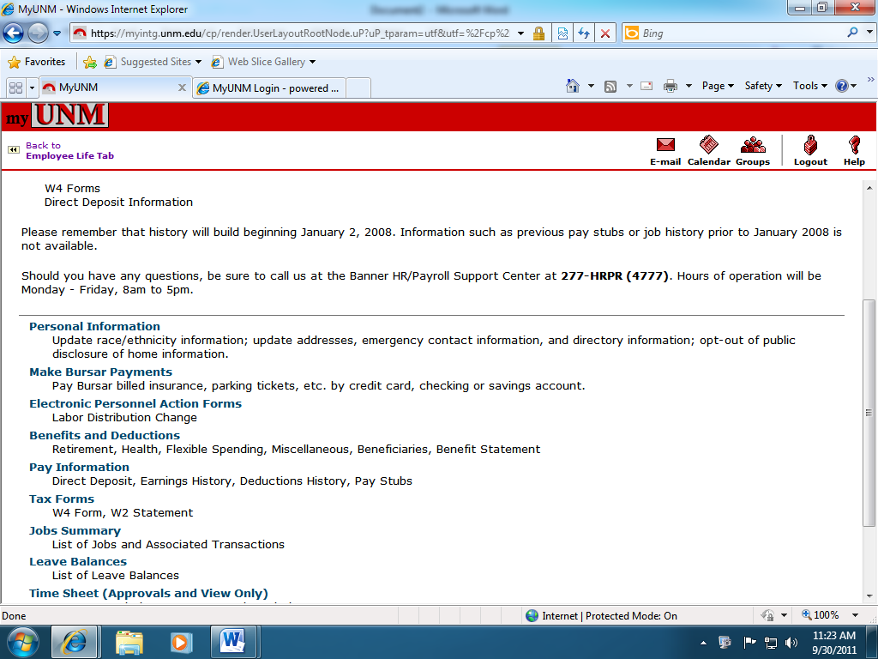

Click on the Electronic Personnel Action Form link

Enter the 9 digitUNM ID for the employee in which an action will be taken. If you do not know the UNM ID numbers go to: <https://eprint.unm.edu/cgi-bin/eprint.cgi> for the following report- PZROEMA

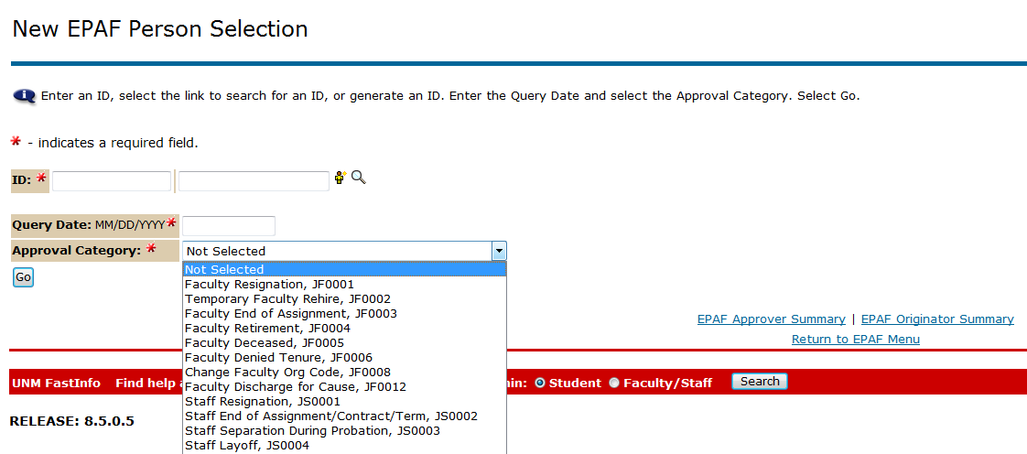

Click “Go” to advance to the next screen

Approval categories represent the purpose of the personnel action - the reason a personnel action is being created.

Query Date displays the date the originator generates a new EPAF. This date will determine which jobs will be displayed.

After selecting the approval category the following screen will be displayed.

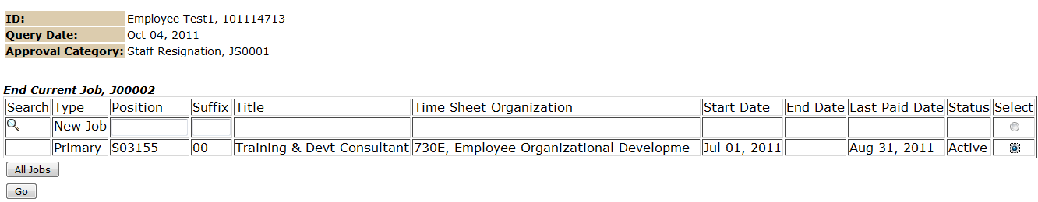

Select the radio button next to the job in which you are taking action. Based on the query date, there may be more than one job displayed.

Click “Go” to advance to the next screen