**EPaf nOTIFICATION SETUP**



**This setup will allow EPAF users to be notified when a transaction is awaiting action.**

Open a browser and enter my.unm.edu into the address field.

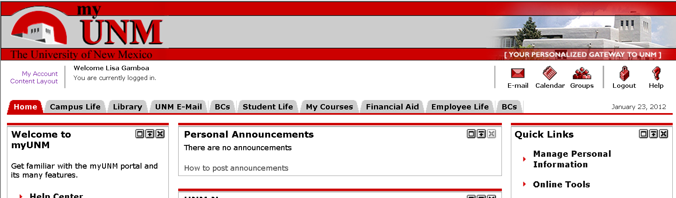

1. Click on the **Content Layout** link in the upper left-hand corner of the myunm page.

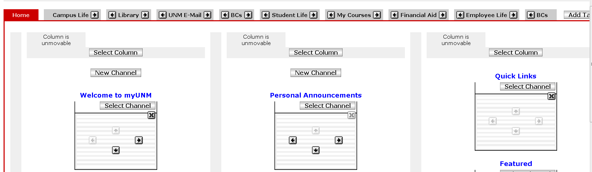

1. Select the **Tab** where you want the channel to be placed.
2. Click on the **New Channel** button at the location where you want the channel to be added.

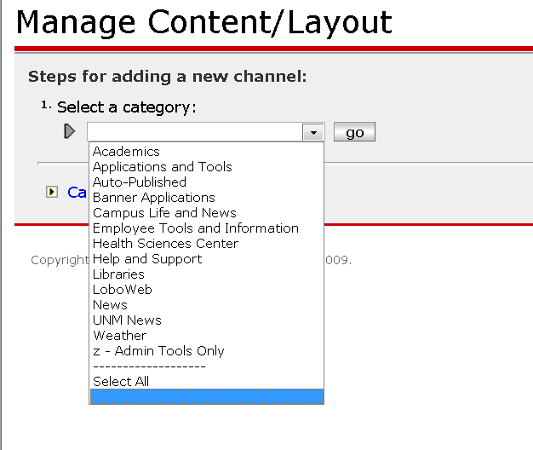

1. Select **Auto-Published** from the drop down menu.
2. Click on the **go** button.

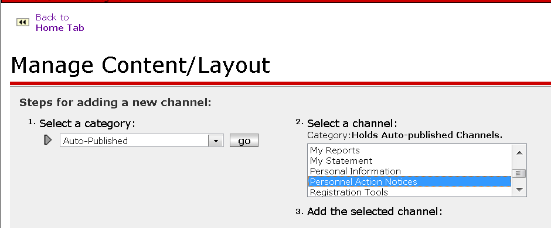

1. Select **Personnel Action Notices** from the Category list.

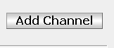

1. Click on the **Add Channel** button.

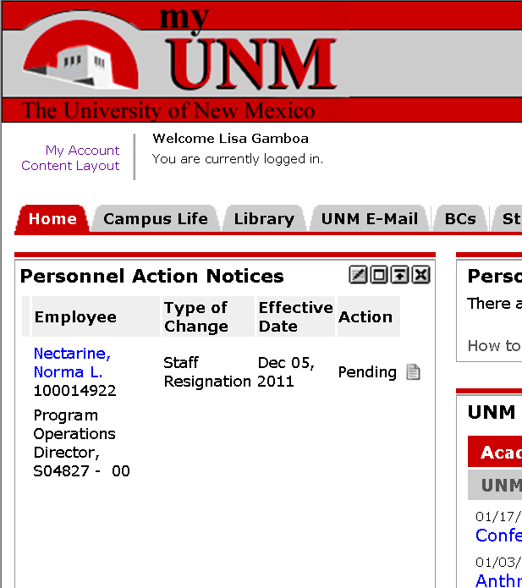

1. Verify the notification channel has been added to your home tab.
2. Click on the individuals name to access the EPAF.

**This process will allow you to select the type of statuses you would like to view in your Personnel Action Notices Channel.**

**EPaf nOTIFICATION maintenance**

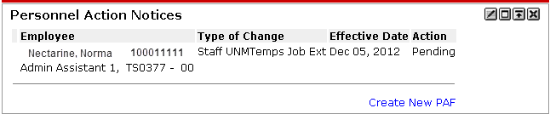

1. Click on the **Edit** button.

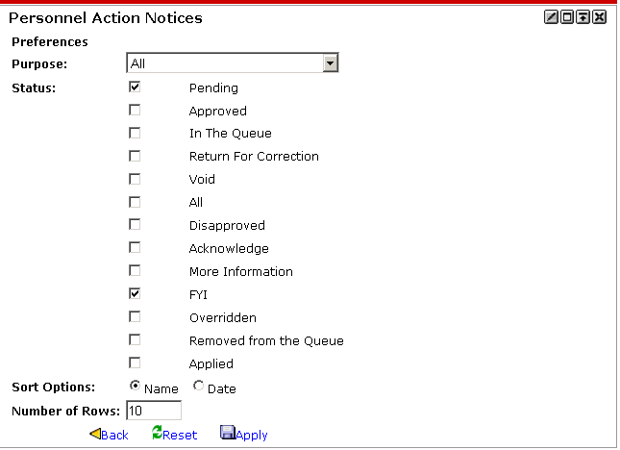

1. Check the boxes next to the **statuses** you want to view in your channel.
2. Select the **Sort Option** you prefer. This will sort by Last Name or Effective Date.
3. Enter the number of rows you want displayed in your channel.
4. Click on the **Apply** button.

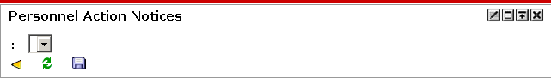

1. Click on the **minimize/maximize** button twice to reset your notifications.

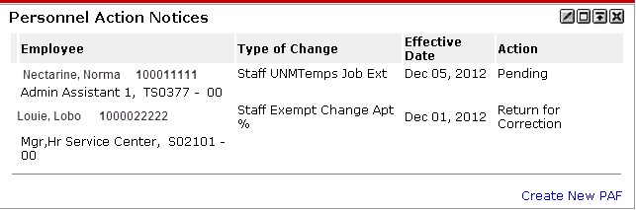

1. The selections made in #2, #3 and #4 have been applied.