

**FACULTY ORG CODE CHANGE EPAF**

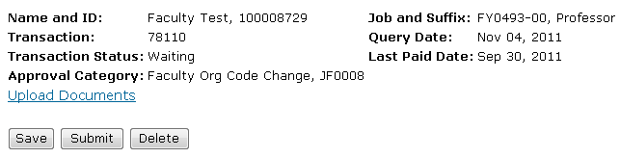

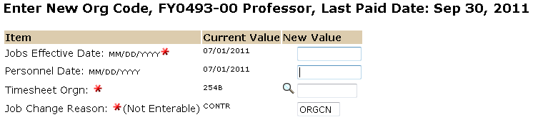

The date the new timesheet org will take effect. Effective date and personnel date should always be the same date.

Enter the new timesheet org code in this field.

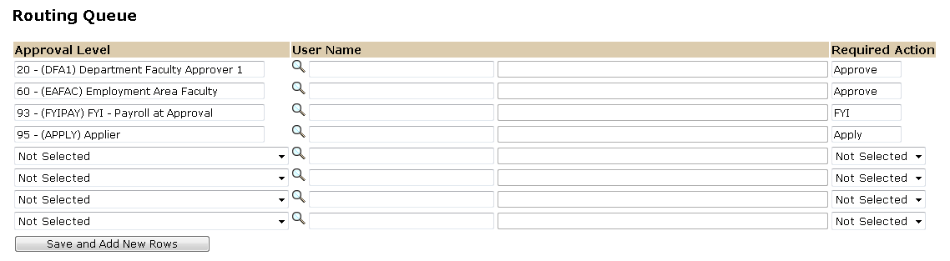

Approval Levels are pre-defined as a standard for system routing. If you require a second level approver, or an FYI, please add as needed.

The Required Action field identifies the appropriate action needed by the user.

The User Name is the person/entity associated with a specific approval level

