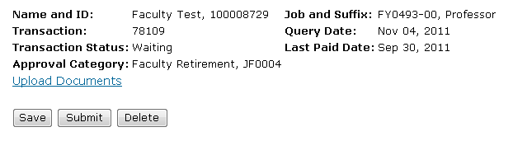

**FACULTY RETIREMENT EPAF**

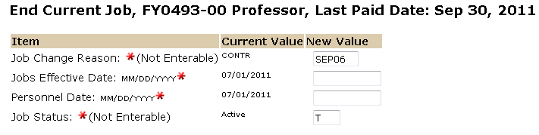

The Effective date reflects the faculty’s last day of employment.

The personnel date is the faculty’s last day of employment.

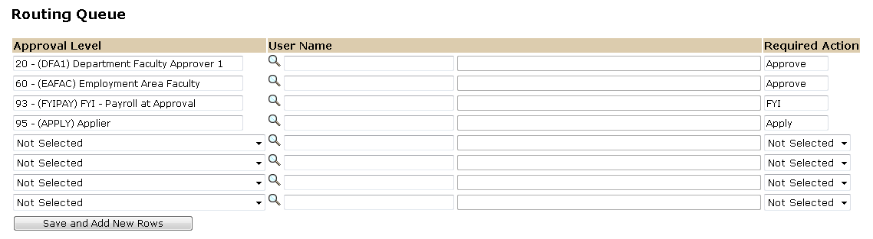

Approval Levels are pre-defined as a standard for system routing. If you require a second level approver, or an FYI, please add as needed.

The Required Action field identifies the appropriate action needed by the user.

The User Name is the person/entity associated with a specific approval level.

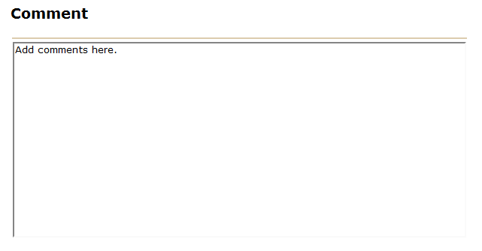

Use the comment box to document forwarding address (if applicable) and leave balances for payout (252 hours maximum per policy 3400.7.2). Checkout form must be submitted prior to last date of employment.



To complete your Faculty Retirement EPAF, click on the upload botton at the top of the page to attach the Retierment letter (Emeritus Letter is optional). For instructions on how to attach a document to your EPAF please reference the BDMS job aid. Please note, you will have 5 minutes to attach your document otherwise the system will log you out and you will be required to log in again.