set up default routing queues job aid
As a Department EPAF Originator, you can establish a pre-defined default routing queue for a particular approval category. The default routing will specify the mandatory levels of approval for that category, assign names to some or all the levels, and identify the action each of the approvers must take.
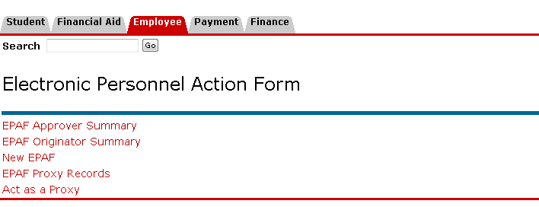

Select EPAF Originator Summary

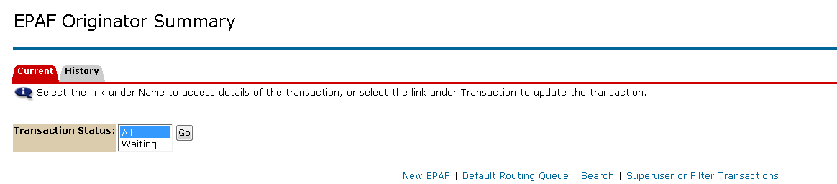

Select Default Routing Queue

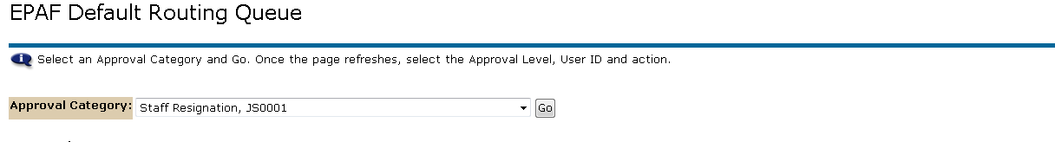
Select the type of action from the drop down menu.
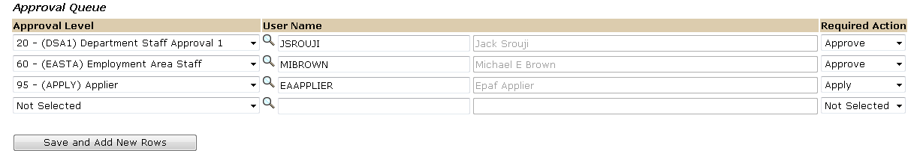
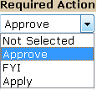
Select required Action.
Enter a NetID for each of the Approval Levels.

