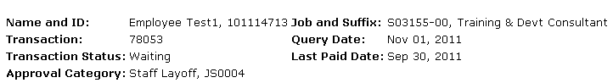

**Staff Layoff**



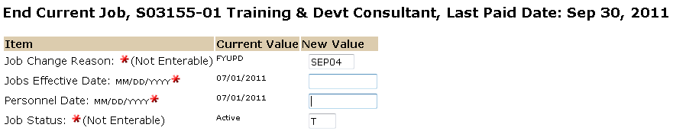

The Personnel Date is the employees last working day.

The Jobs Effective Date reflects the employees last working day unless this is a retroactive action and the employee has already been paid. In this case use the last paid date. See “Understanding EPAF Transaction Dates” for more information.

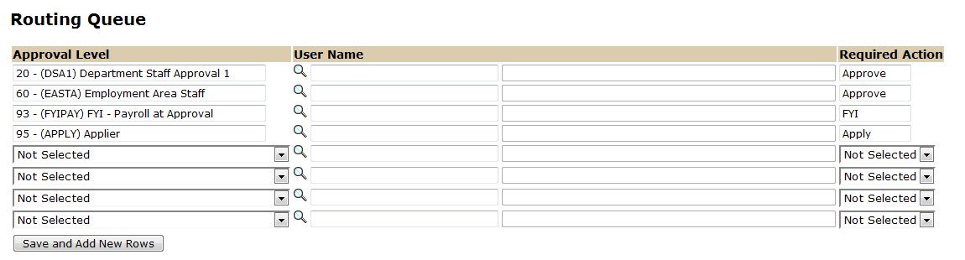

Approval Levels are pre-defined as a standard for system routing. If you require a second level approver, or an FYI, please add as needed.

The Required Action field identifies the appropriate action needed by the user.

The User Name is the person/entity associated with a specific approval level.

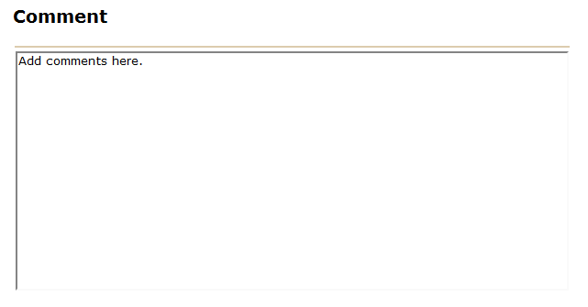

Use the comment box to document forwarding address (if applicable) and leave balances for separating employee.



To complete your Staff Layoff EPAF, click on the **Upload Documents** button at the top of the page to attach the layoff notification letter. For instructions on how to attach a document to your EPAF please reference the Attaching Documents Job Aid. Please note, you will have 5 minutes to attach your document otherwise the system will log you out and you will be required to log in again.