

**STAFF NON-EXEMPT CHANGE IN APPOINTMENT PERCENT EPAF**

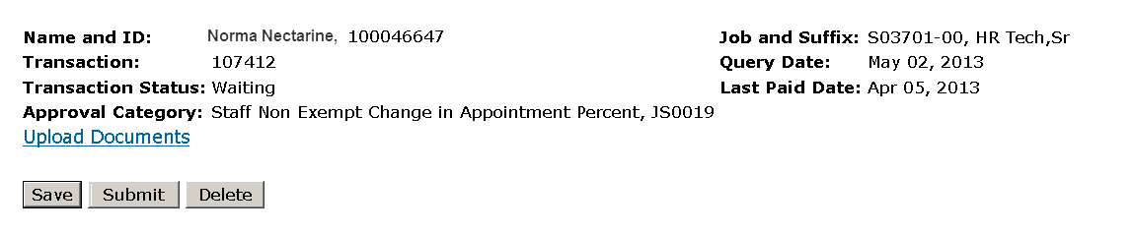

The Jobs Effective Date reflects the date the employee will begin being paid at this percent. If this is a retroactive transaction then use the day after the last paid date.

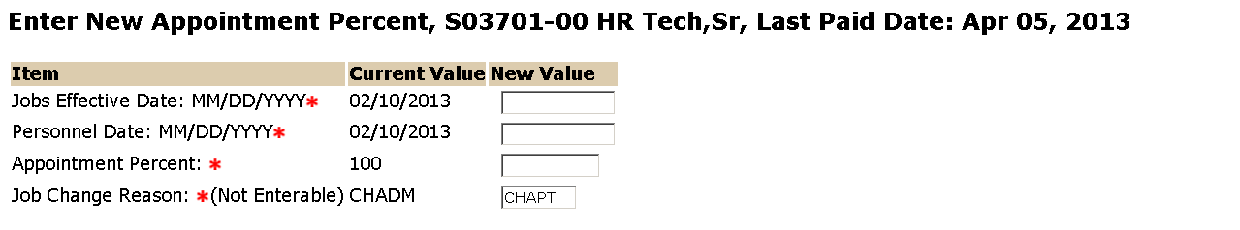

Enter the new appointment percent. This percent must be greater than 1. For example 50% should be entered as 50 not .50

The Personnel Date is the date this appointment percent will take effect.

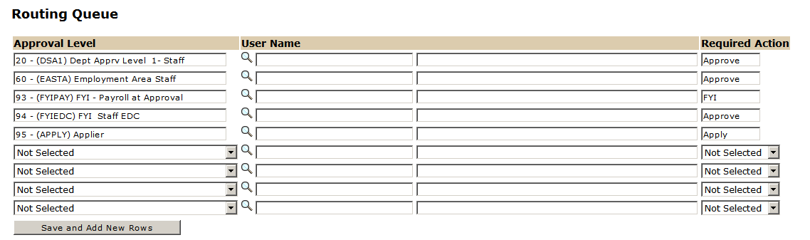

Approval Levels are pre-defined as a standard for system routing. If you require a second level approver, or an FYI, please add as needed.

The User Name is the person/entity associated with a specific approval level.

The Required Action field identifies the appropriate action needed by the user.

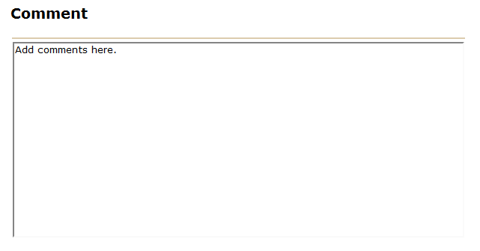

If the appointment percent drops below 50 percent, use the comment box to communicate A/L and S/L balances.



To complete your Staff Non-Exempt Change in Appointment Percent EPAF, click on the upload button at the top of the page to attach the Change in Appointment Percent Form. For instructions on how to attach a document to your EPAF please reference the Attaching Documents job aid. Please note, you will have 5 minutes to attach your document otherwise the system will log you out and you will be required to log in again.