

**staff Non-Exempt shift update**

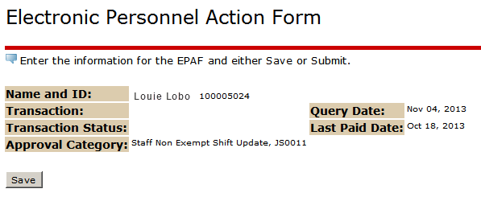

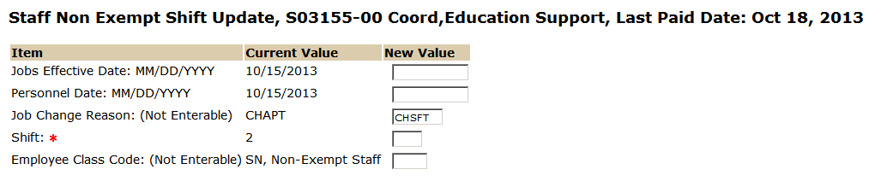

Enter new shift- If this shift change results in a supervisor change you must also process an [Update Supervised By EPAF](http://epaf.unm.edu/job-aids.php).

Enter the date this update will take effect. If this is retroactive transaction, then use the day following the last paid date.

Personnel Date should be the same as the effective date unless this transaction took place prior to the last paid date.

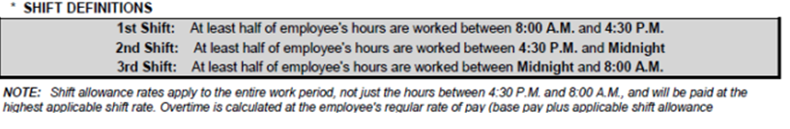

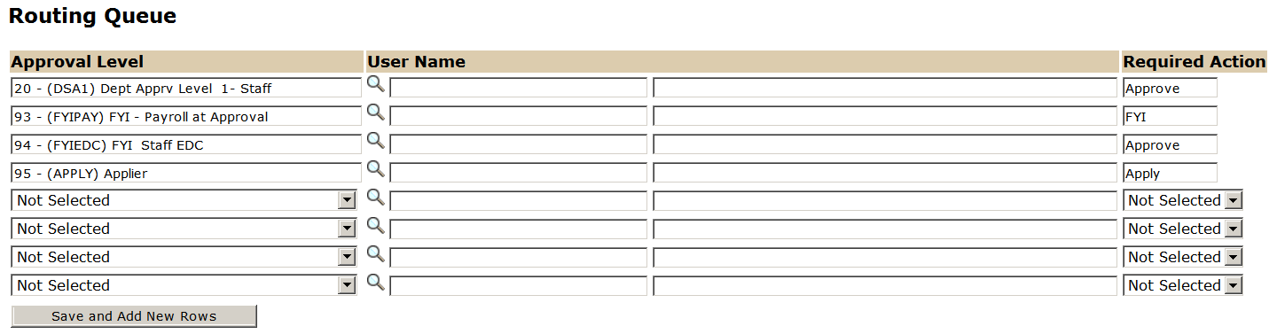

The User Name is the person/entity associated with a specific approval level. See [Routing Lists Job Aid](http://epaf.unm.edu/job-aids.php) to select the correct user.

The Required Action field identifies the appropriate action needed by the user.

Approval Levels are pre-defined as a standard for system routing. If you require a second level approver, or an FYI, please add as needed.

