

**Student Discharge for Cause EPAF**

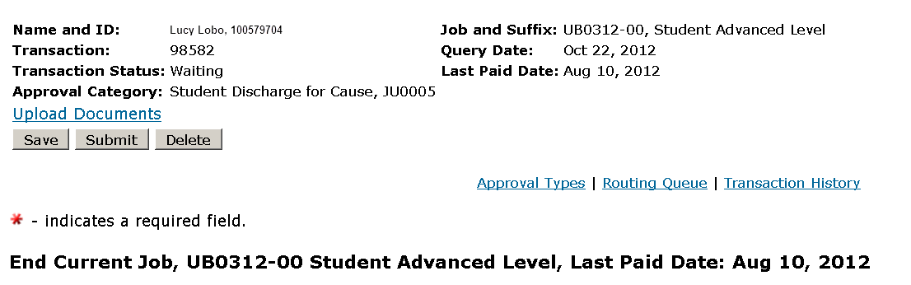

The Effective date reflects the employees last working day unless this is a retroactive action and the employee has already been paid. In this case use the last paid date.

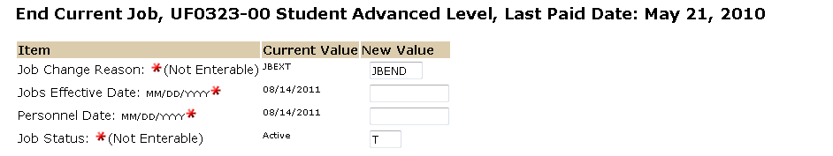

The personnel date is the student’s last working day.

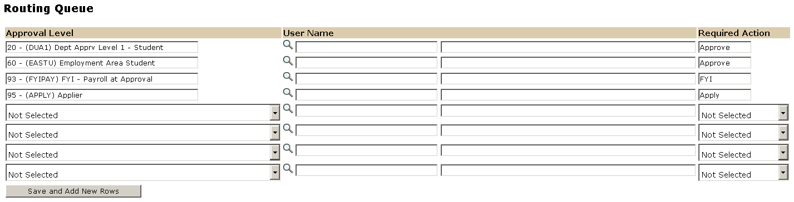

Approval Levels are pre-defined as a standard for system routing. If you require a second level approver, or an FYI, please add as needed.

The User Name is the person/entity associated with a specific approval level.

The Required Action field identifies the appropriate action needed by the user.

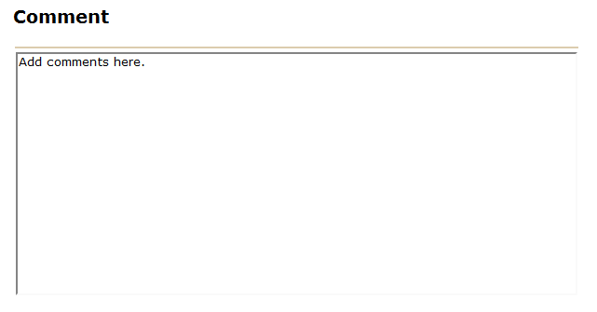

If applicable, please document the student’s forwarding address and reason for discharge.



OPTIONAL: If you chose to attach a document please click on the upload botton at the top of the page . For instructions on how to attach a document to your EPAF please reference the “[Attaching Documents](http://epaf.unm.edu/job-aids.php)” job aid. Please note, you will have 5 minutes to attach your document otherwise the system will log you out and you will be required to log in again.