

**Student Separation During Probation EPAF**

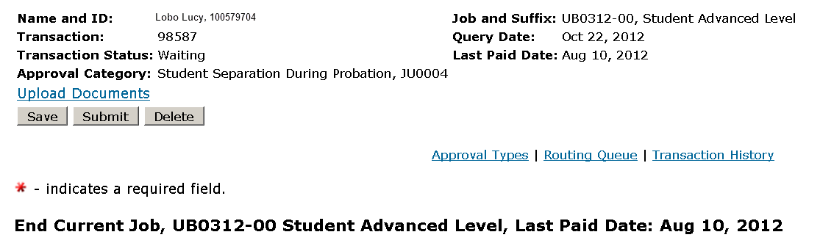

The personnel date is the student’s last working day.

The Effective date reflects the employees last working day unless this is a retroactive action and the employee has already been paid. In this case use the last paid date.

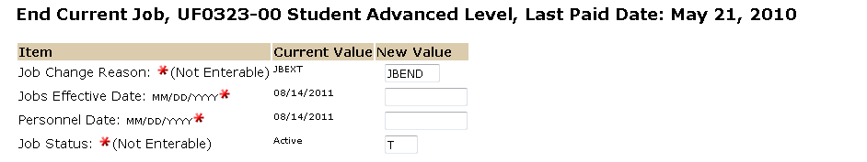

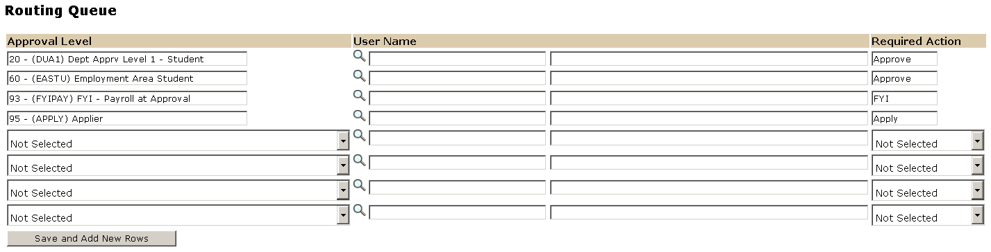

The User Name is the person/entity associated with a specific approval level.

Approval Levels are pre-defined as a standard for system routing. If you require a second level approver, or an FYI, please add as needed.

The Required Action field identifies the appropriate action needed by the user.

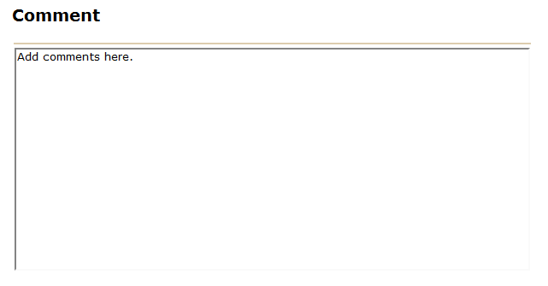

If applicable, please document the student’s forwarding address.



OPTIONAL: If you chose to attach a document please click on the upload botton at the top of the page . For instructions on how to attach a document to your EPAF please reference the “[Attaching Documents](http://epaf.unm.edu/job-aids.php)” job aid. Please note, you will have 5 minutes to attach your document otherwise the system will log you out and you will be required to log in again.