

**unmtemps Job Extension epaf**

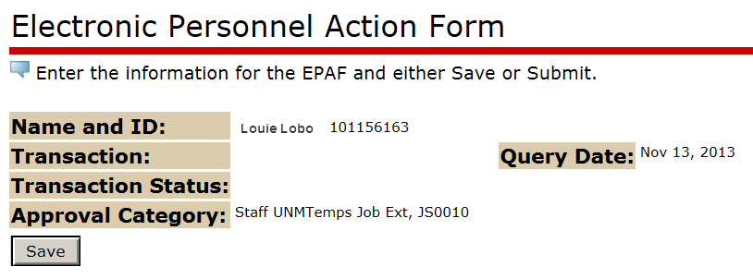



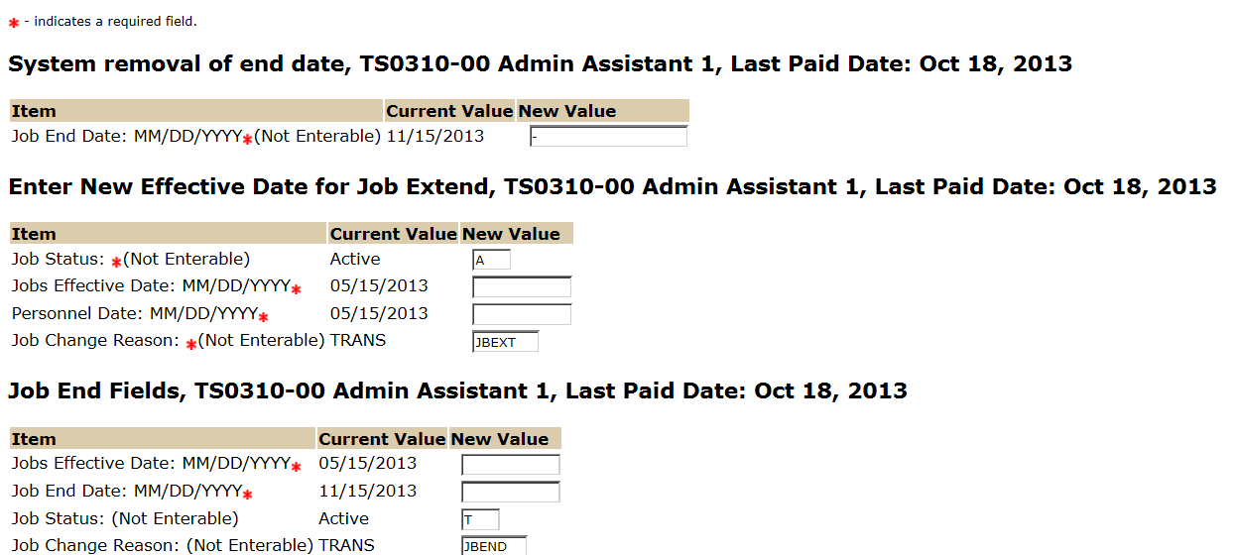

The Job Effective Date and the Job End Date should reflect the date the new the assignment is scheduled to end (all dates should be the same).

The Job Effective and Personnel Date should reflect the new effective date. This date should be the next calendar day after the current assignment end date. If this is a retroactive action the effective date should be the day after the last paid date and the personnel date should be the day after the current assignment end date.

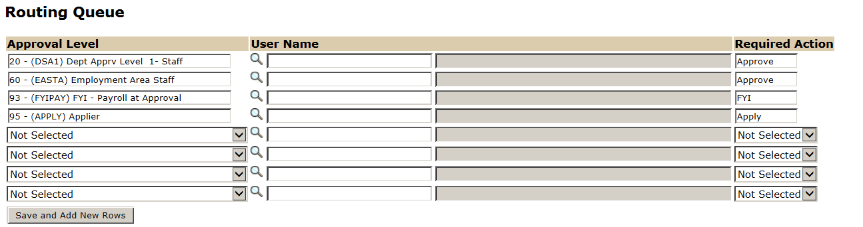

The User Name is the person/entity associated with a specific approval level. See [Routing Lists Job Aid](http://epaf.unm.edu/job-aids.php) to select the correct user.

The Required Action field identifies the appropriate action needed by the user.

The Routing Queue is a Pre-defined standard of approval levels. If you require a second level approver or an FYI, please add as needed.

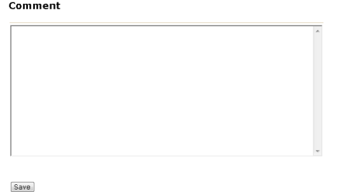

Assignments through UNMTemps should not exceed six (6) months unless preapproved by the UNMTemps Manager. If requesting an extension past six (6) months from the original hire date, you must document a justification for an extension in the Comment section for HR consideration.